Machine Learning
Lecture 1
What is Machine Learning
Machine learning (ML) is a type of artificial intelligence (AI) that allows computers to learn from data and make predictions without being explicitly programmed.
In simple words:
Machine Learning is like teaching a computer using examples, not rules.
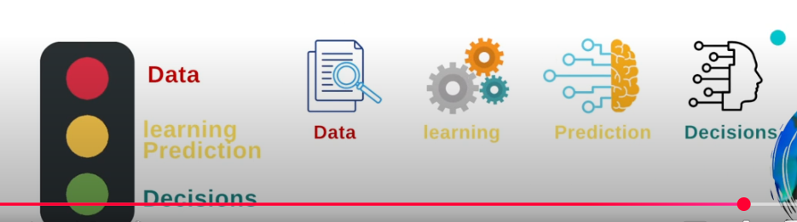
Example
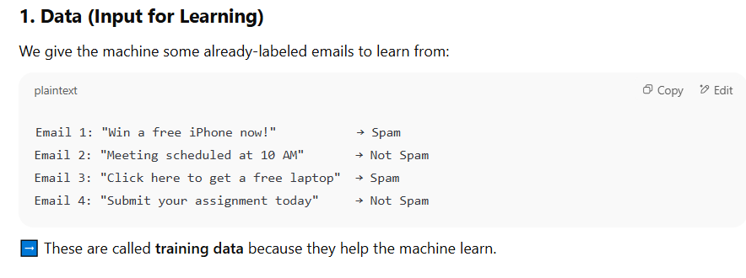
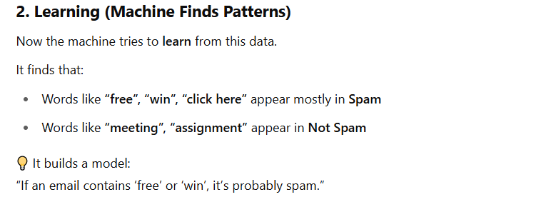
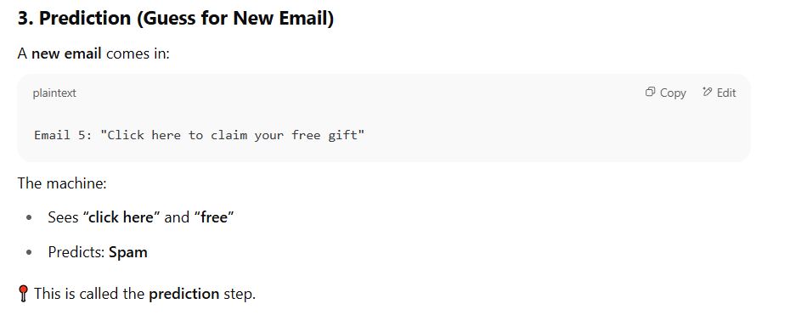
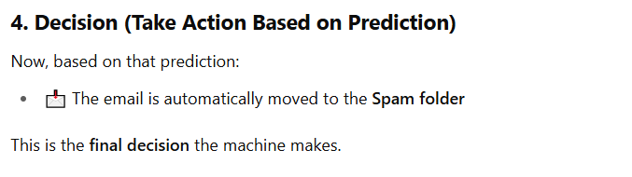
But how is AI different from traditional Computer Science?
Traditional Computer Science
- Computers follow exact instructions that humans write.
- You tell the computer step by step how to solve a problem.
- Example: A program to calculate your grades—you write the rules, and the computer just follows them.
Artificial Intelligence (AI)
Computers try to think or act like humans.
They learn from data or experience instead of only following fixed rules.
Example: A program that recognizes faces in photos—it figures out patterns from lots of pictures instead of you telling it exactly how a face looks.
In short:
- Traditional CS → computer follows rules.
- AI → computer learns rules and makes decisions on its own.
Traditional Problems (solved using normal programming rules):
- Play an audio/video file → Make the computer play a song or video when you ask.
- Display a text file on screen → Show the contents of a text file for the user to read.
- Perform a mathematical operation on numbers → Add, subtract, multiply, or divide numbers.
- Sort an array of numbers → Arrange numbers from smallest to largest (or largest to smallest).
- Search for a number in a list of numbers → Find if a number exists in a list and where it is.
These are called traditional problems because the rules are clear, and the computer can follow exact steps to solve them.
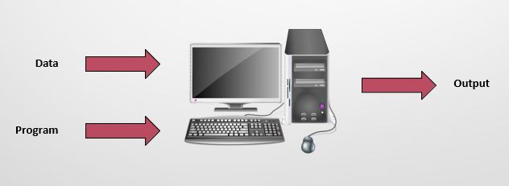
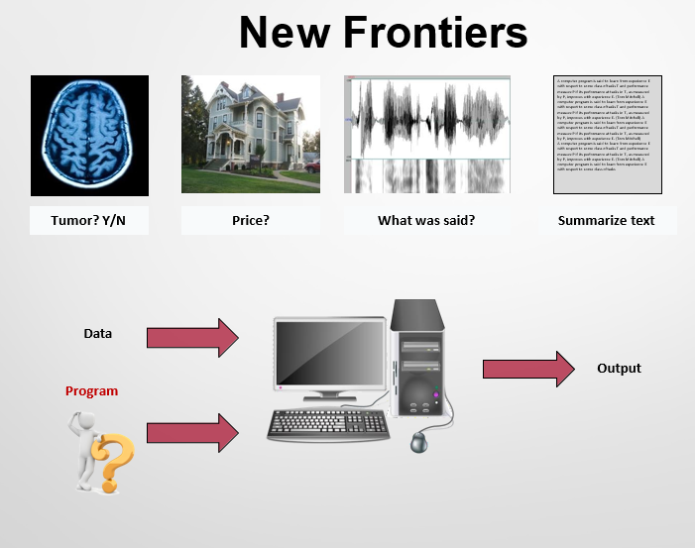
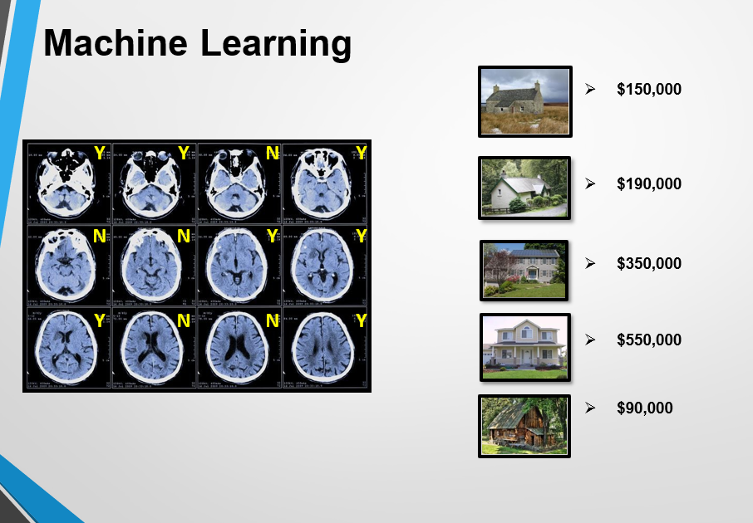
Traditional CS
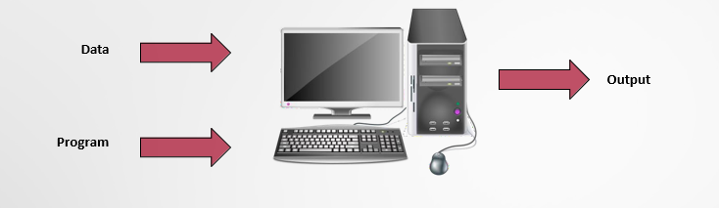
Machine Learning
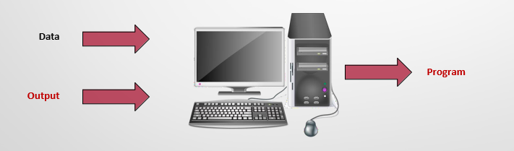
Machine Learning Pipeline
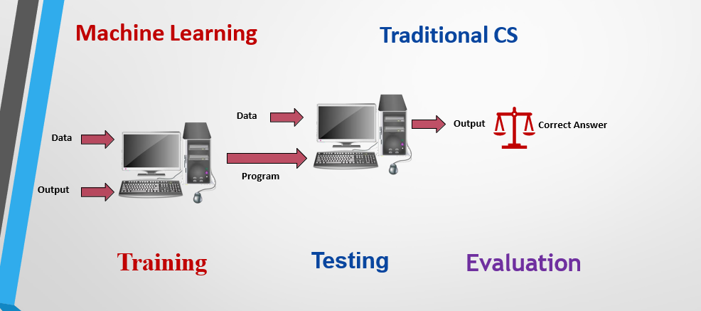
Informal: ML is when algorithms (computer programs) get better at a task the more they practice or get experience.
What’s the difference between AI and ML?
Artificial Intelligence (AI)
- AI is a bigger concept.
- It’s about making computers act like humans—thinking, reasoning, or solving problems.
- AI can use rules (traditional programming) or learning (ML).
- Example: A chatbot that answers questions intelligently.
Machine Learning (ML)
- ML is a subset of AI.
- It means make a better machine – not necessarily emulating a human
- It focuses on teaching computers to learn from data and improve automatically.
- ML does not need exact instructions—it figures out patterns from data.
- Example: Netflix recommends movies based on what you watched.
In short:
- AI = making machines smart.
- ML = a way for machines to get smart by learning from data.
What’s the buzz all about?
It’s talking about how AI language models (like ChatGPT) work and why they are important.
1. Language Model
A language model is a computer program that learns how words usually appear together in sentences.
It studies a lot of text to guess which words make sense next.
Example:
If you type: “The cat is on the…”,
the model might guess “table” or “bed” because those words commonly follow.
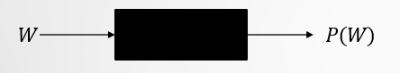
2. Large Language Models (LLMs)
These are bigger and smarter language models trained on huge amounts of data — books, websites, articles, etc.
They can understand and create text that sounds natural and human-like.
Example:
ChatGPT is a Large Language Model. It can write essays, answer questions, or even chat like a person.
3. Chatbots and Conversational Agents
These are apps or programs that use language models to talk to humans.
They can answer your questions or help you do tasks.
Example:
- ChatGPT helps you learn or write.
- Siri and Alexa answer your voice commands.
4. Reinforcement Learning from Human Feedback (RLHF)
This means humans help train AI by telling it which answers are good, and which are not.
The AI then learns to give better responses next time.
Example:
If ChatGPT gives a wrong or rude answer, a human trainer marks it as bad.
The AI learns from that feedback and avoids it in the future.
5. Semantic Spaces
These are like maps inside the computer’s brain where meanings of words, images, and sounds are connected.
It helps AI understand that related things have similar meanings.
Example:
The AI knows that “king” and “queen” are related, or that “dog” and “bark” belong together.
It can also connect a picture of an apple with the word “apple” and the sound “aah-pul”.
“At the heart of every intelligent machine is a classifier!”
It means that the main part of an intelligent machine (like AI) is something that can classify — or decide what something is based on what it learns.
What is a classifier?
A classifier is a part of AI that sorts or labels information into categories.
It learns patterns from data and then recognizes them in new examples.
Example:
- If you show an AI many pictures of cats and dogs,
the classifier learns the difference.
- Later, if you show a new picture, the AI says:
“This looks like a cat” or “This looks like a dog.”
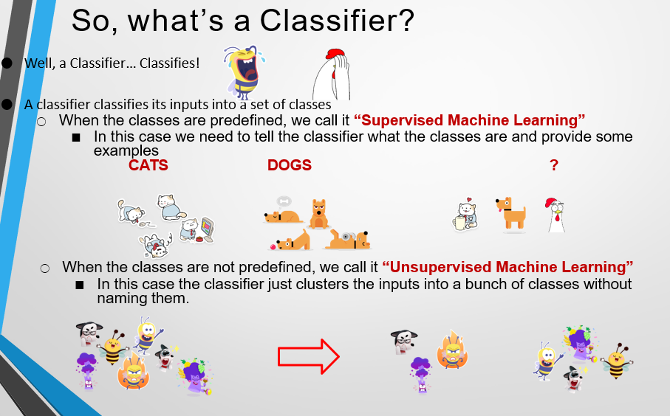
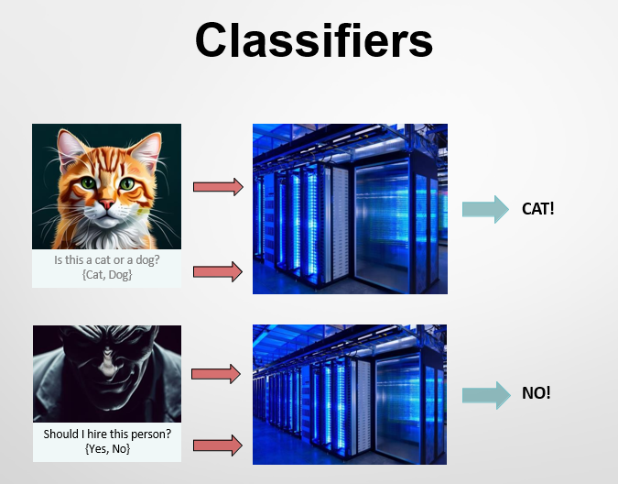
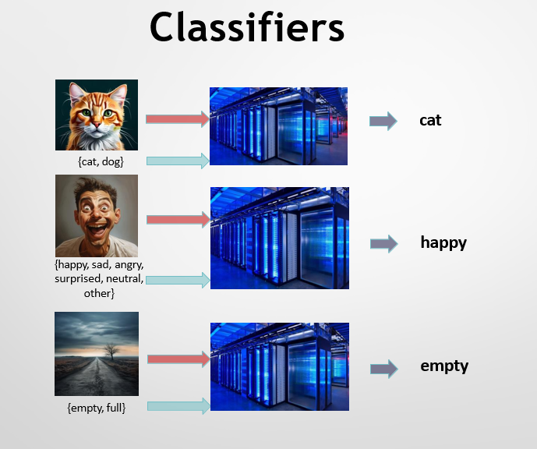

Feature
A feature is a piece of information or characteristic that helps an AI or machine learning model understand and make decisions about data.
You can think of features as the clues or important details the computer looks at.
Example 1: (Animals)
If you’re training an AI to tell cats and dogs apart:
Features could be:
- Ear shape 🐾
- Tail length
- Fur color
- Sound (meow or bark)
These features help the AI decide: “This is a cat” or “This is a dog.”
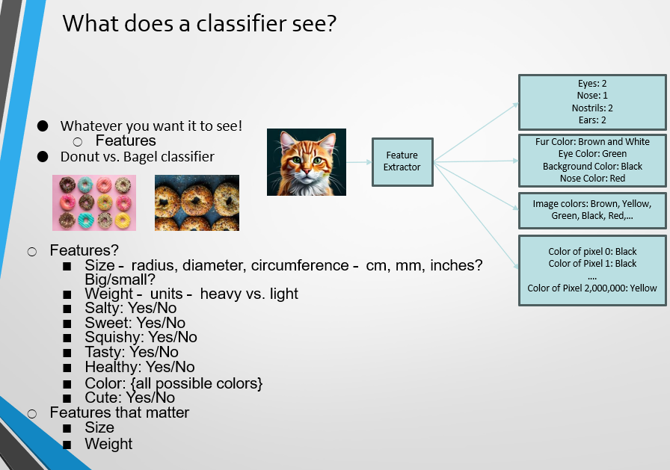

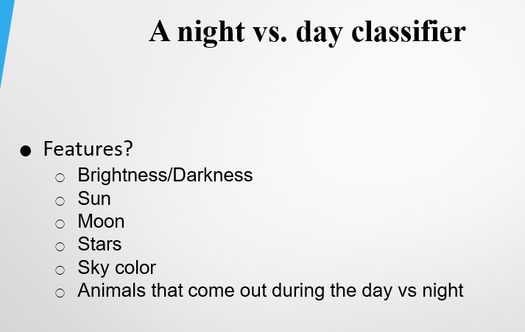



Unsupervised Learning
Goal:
The main aim of unsupervised learning is to find hidden patterns or groups inside the data — this process is called clustering.
It helps the computer to discover natural divisions (or “subpopulations”) in data without any labels.
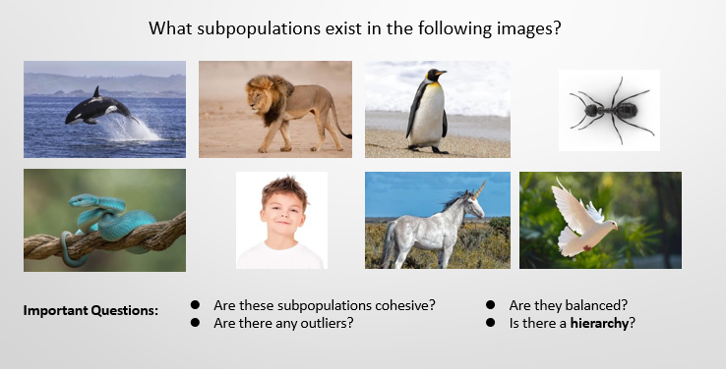

Understanding Subpopulations in Images
When we look at a dataset or image, we might notice that it has different groups (subpopulations) that share similar features.
- Orca (whale) – Marine animals (aquatic mammals)
- Lion – Land mammals, carnivores, terrestrial predators
- Penguin – Birds (flightless), cold-climate dwellers
- Ant – Insects, social species with colony structure
- Lizard – Reptiles, cold-blooded animals
- Child (human) – Humans, primates, mammals
- Unicorn – Mythical creatures (fictional subgroup)
- Dove – Birds (flying), often symbolizing peace
Possible Subpopulations
- Mammals: Orca, Lion, Human
- Birds: Penguin, Dove
- Reptiles: Lizard
- Insects: Ant
- Mythical beings: Unicorn
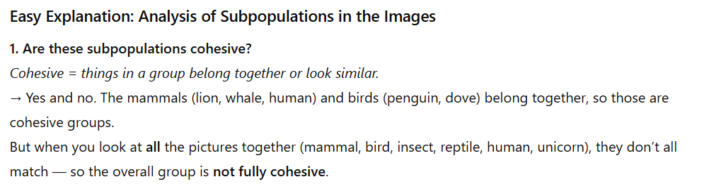
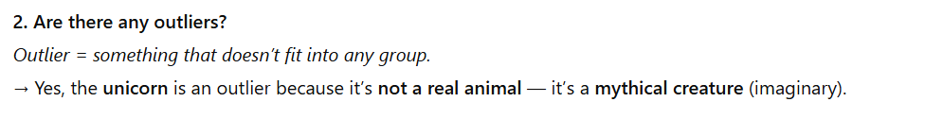

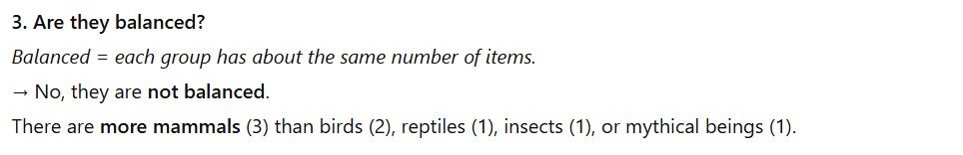
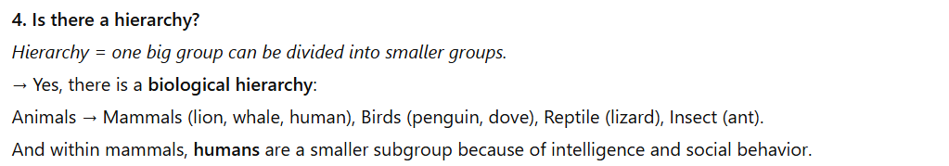
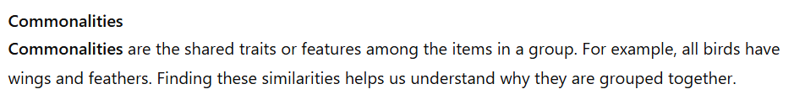
Data sets
A dataset is a collection of related data that is organized in a structured way so it can be used for analysis or training a machine learning model.
Example:
A table showing students’ names, ages, study hours, and test scores is a dataset. Each row represents one student, and each column represents a type of information (like age or score).
How do we obtain large amounts of data?
To train a machine learning model, we need a lot of data so the computer can learn from examples. This data comes from different places and people.
1. Real Interactions
We collect data from real-life activities like phone calls, chats, or website use.
Example: Recordings from call centers help train computers to understand human speech.
2. Expert Annotators
Sometimes, trained experts label data correctly so it’s accurate.
Example: Doctors label X-ray images as “normal” or “diseased” to help train medical AI systems.
3. Crowdsourcing
Crowdsourcing means getting help from a large number of people online to do small tasks that together create a big dataset for AI training.
Example: People on Amazon Mechanical Turk are paid to label photos or text for AI training.
4. reCAPTCHA
When websites ask you to “click all pictures with cars” or “type the letters shown,” that’s reCAPTCHA — it collects labeled data while checking if you’re human.
Example: Clicking on traffic lights helps train self-driving car models.
5. Tagging
Tagging means adding labels, names, or keywords to data like photos, videos, or text so that computers can understand what’s in them. These tags become training data for machine learning models.
How It Works Step by Step:
- Users Add Tags:
When people upload photos or videos on social media (like Facebook or Instagram), they often tag friends or objects — for example, typing “Ali” on a friend’s face or adding hashtags like #dog or #sunset.
- Data is Collected:
These tags tell the system what or who is in the image. For instance, if a face is tagged as “Ali” many times, the AI learns that this face belongs to that person.
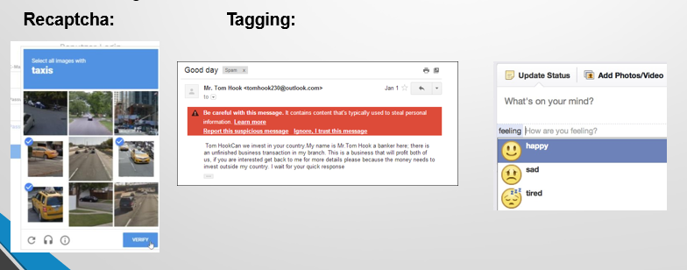
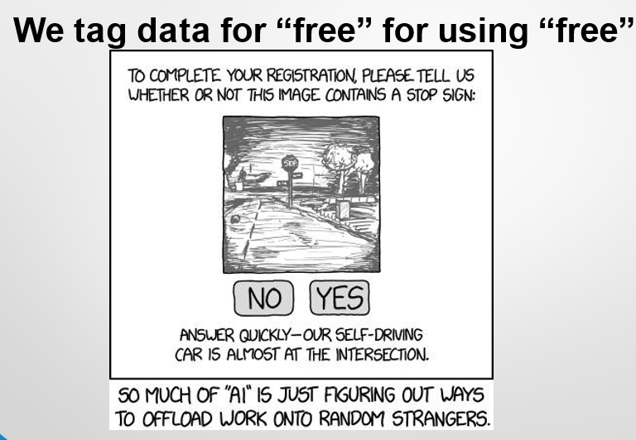

Applications
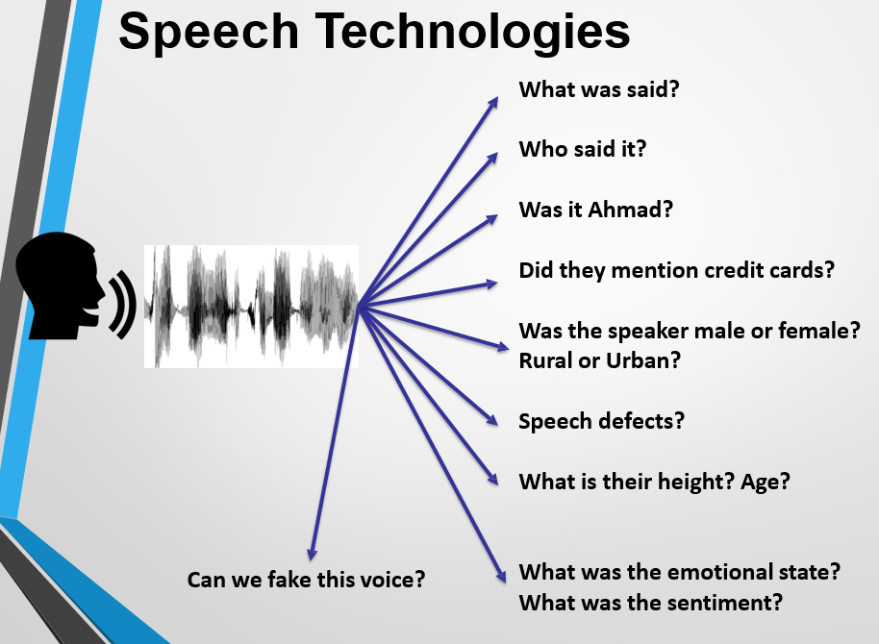
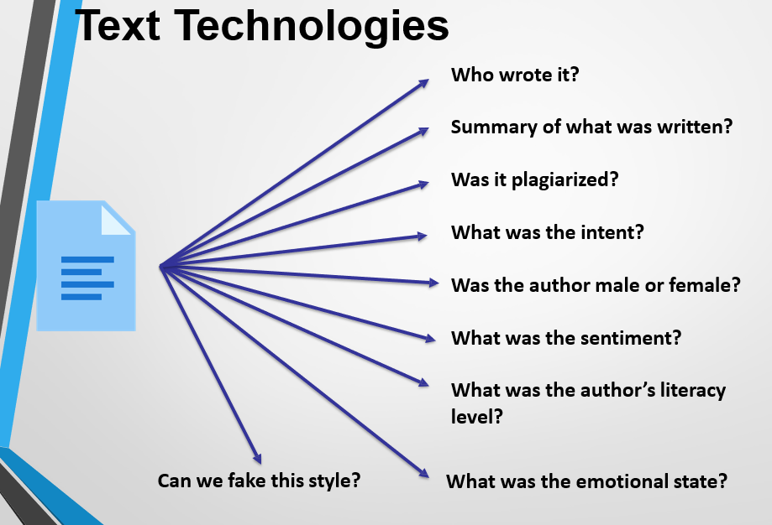
Challenges of Machine Learning – Explainability
One of the main challenges in Machine Learning (ML) is explaining why and how a model makes a certain decision.
1. Problem of Unwanted Learning
Sometimes, an ML model learns from the wrong features instead of the real patterns humans expect.
- If all dogs in the training data wear collars, and no cats do, the model might learn to identify a collar as a “dog” instead of recognizing the animal itself.
- If all horse images have a copyright notice, the model might learn to detect that notice instead of the horse.
Example: The ML model says “This is a dog” — but it’s actually just seeing a collar, not the dog.
2. Explainable ML
Explainable Machine Learning means the results and decisions made by the model should be clear and understandable to humans.
It helps users know why the model made a certain prediction.
Example: Instead of just saying “Spam email detected,” the system should explain — “because it contains words like ‘win money’ and ‘click here’.”
3. Black-Box Problem
Traditional ML systems often act like a black box, where we can see the input and output but not what happens in between.
Explainable ML tries to open this black box so we can trust and verify the model’s reasoning.
Example: Doctors using AI for diagnosis want to know why the system thinks a patient has a disease — not just the final answer.
Challenges – Fairness in AI
Another big challenge in Artificial Intelligence (AI) is Fairness. AI systems can sometimes make unfair or biased decisions because they learn from human data, which may already have biases.
1. Bias from Society
AI models are trained on data collected from people, and if that data has social or cultural bias, the AI will learn and repeat it.
Example: If job data mostly includes male employees, the AI might think men are more suitable for the job
2. Bias from Human Taggers
Sometimes, the people who label or tag the data can be biased too.
Example: A person might wrongly mark a recording as “misinformation” just because of someone’s accent or gender — and the AI will learn that same unfair pattern.
3. AI in Hiring Decisions
AI is now used in many companies to screen job applications. But it can unintentionally reject good candidates.
Example: In the US, around 72% of resumes are filtered by AI systems before a human ever sees them — so if the AI is biased, many deserving people may never get a chance.
4. Decisions That Affect Lives
AI is now used in many important areas like checking people for immigration, deciding who gets bank loans, calculating credit scores, or even identifying criminal suspects.
If the AI system has bias in its training data, it might make unfair decisions that hurt people.
Example:
If most people in the training data who got bank loans were from rich areas, the AI might wrongly assume that people from poor areas don’t deserve loans — even if they have a good income and can pay it back.
Machine Learning in Low-Resource Settings
In some parts of the world, especially in developing regions, there isn’t enough data or technology available to train machine learning models properly. This is called a low-resource setting.
For example, in Pakistan, there are around 71 languages, but most speech recognition systems only work well for English — and even Urdu has very limited support. This makes it hard to build AI tools that understand local languages.
Why Is This Important?
If we don’t develop AI for these languages, many people will be left out of technology benefits like voice assistants, translation apps, or automated services.
Creating ML tools for all languages ensures equal access, better communication, and inclusion for everyone — not just for those who speak widely used languages.
Managing Expectations
- Many people have unrealistic ideas about what Artificial Intelligence (AI) can do. Some believe AI will replace humans completely — becoming caring friends, taking over creative jobs like art or music, or even becoming smarter than humans.
- Others fear that AI might turn against humans, become self-aware, or lead to something like robots taking over the world (like in movies such as Terminator).
A Balanced View of AI – “Just Right”
AI should be seen as a helpful tool, not a replacement for humans. It can support people in their work, make industries more efficient, and improve accuracy and performance in many areas like healthcare, education, and business. AI can create a positive impact on society when used responsibly.
However, there are also real challenges that must be controlled. AI can affect jobs, be difficult to understand, or show bias if not trained fairly. To use AI safely, we need rules, fairness, and failure-safe systems to prevent harm.
Responsible AI
Responsible AI means using and developing Artificial Intelligence in a careful and ethical way so that it benefits people and does not cause harm.
It should be explainable, meaning people can understand how and why they make decisions. It must also be fair and unbiased, treating everyone equally without discrimination. AI should always follow ethical rules, respect privacy and getting consent before using personal data.
AI systems should also be safe, avoiding harm to people or society, and regulated by laws to ensure they are used correctly.

Lecture 2
Lifecycle of ML
- Data Collection – Gathering raw data for the problem.
- Data Preprocessing – Cleaning and organizing the data.
- Choosing a Model – Selecting the right algorithm to use.
- Training the Model – Teaching the model using the data.
- Evaluating the Model – Checking how well it performs.
- Fine-tuning – Improving the model for better accuracy.
- Prediction or Inference – Using the trained model to make results.
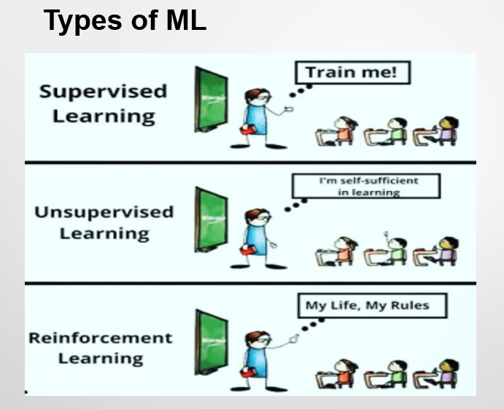

Supervised Machine Learning
Supervised Machine Learning is a type of machine learning where the model is trained using labeled data — meaning each input already has a correct output.
The system learns from examples so it can predict the right answers for new, unseen data.
Example:
If you train a model with pictures labeled as “cat” or “dog,” it learns to recognize and classify new pictures correctly as cats or dogs.
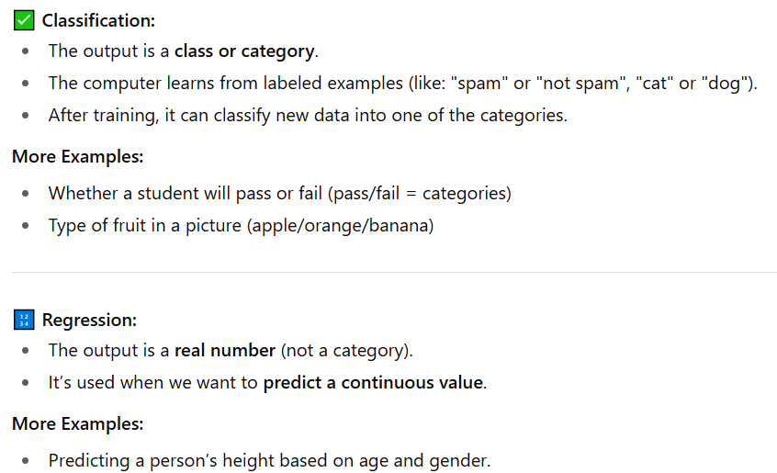
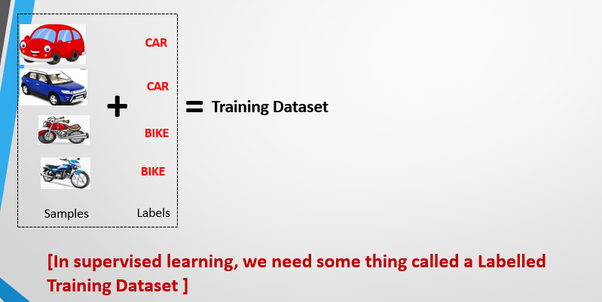
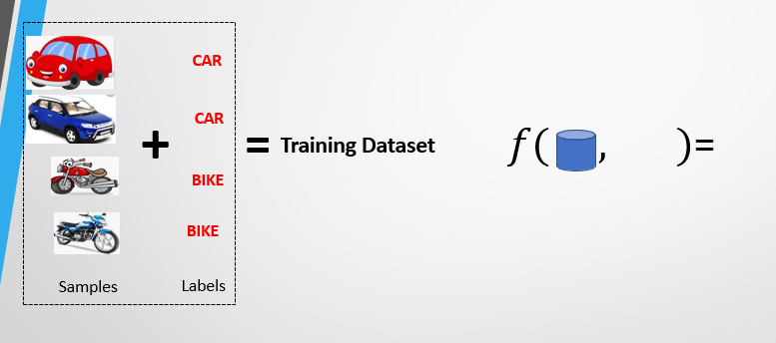
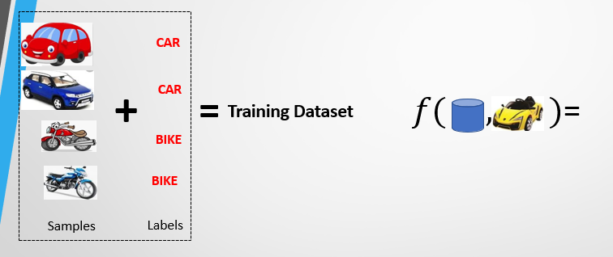
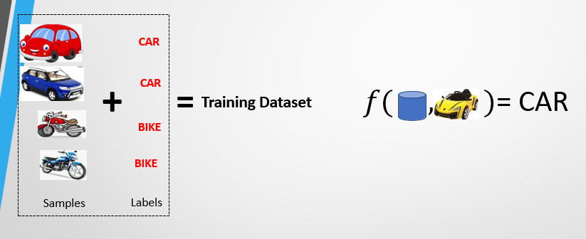
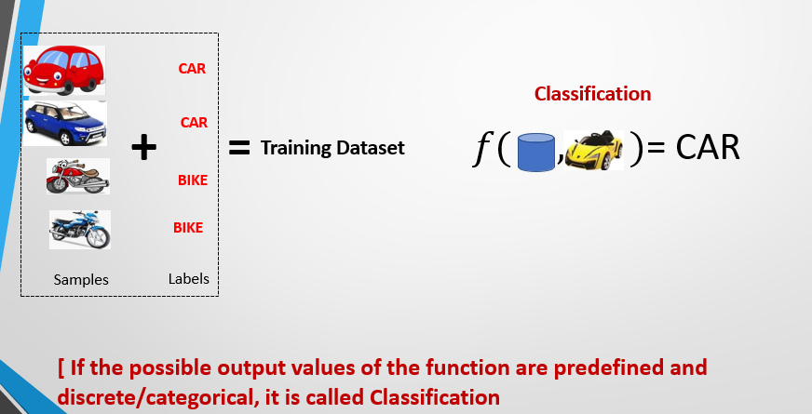
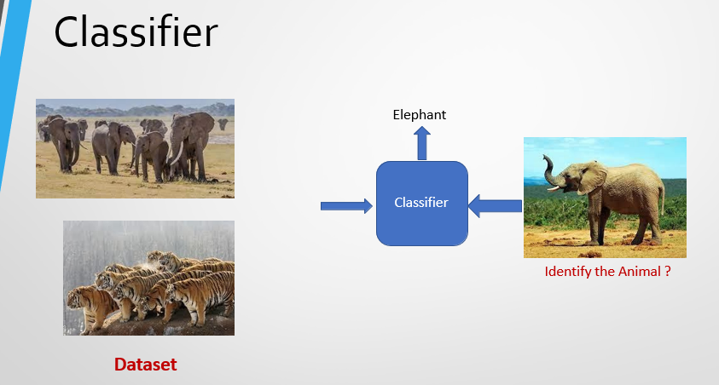
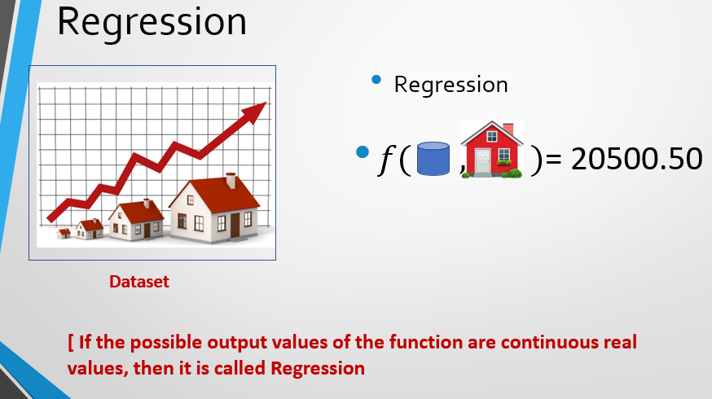
The Classification and Regression problems are called supervised learning because the model learns from labeled data, where the correct answers (ground truth labels or values) are already known. These labels act as the model’s experience, helping it make decisions based on given examples.
2. Unsupervised Machine Learning?
Unsupervised ML is when the computer learns from data without any labels or answers.
It finds patterns, groups, or structures in the data by itself.
What is Clustering?
Clustering is when the machine groups similar items together based on their features.
Example 1: Customer Segmentation
- Data: Age, income, shopping habits
- Goal: Group customers into types like budget buyers, frequent shoppers, etc.
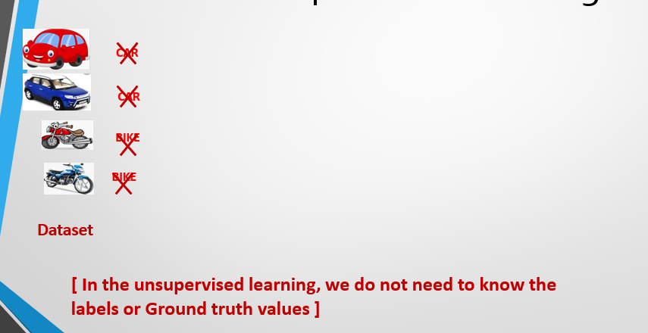
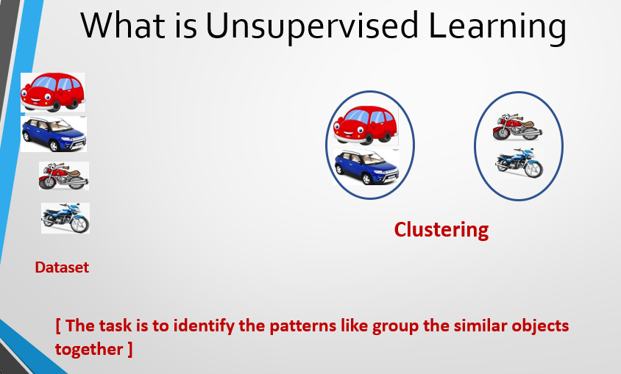
Association Rule Mining
Association Rule Mining is a data mining technique used to find patterns, relationships, or connections between items in large datasets.
It helps discover how items are linked to, for example, in shopping data, it can show which products are often bought together.
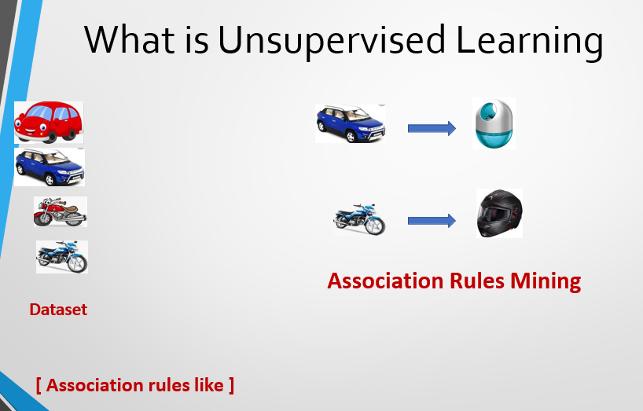
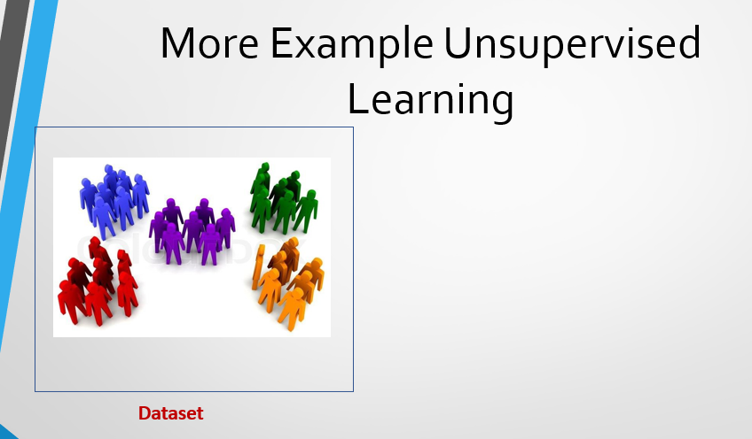
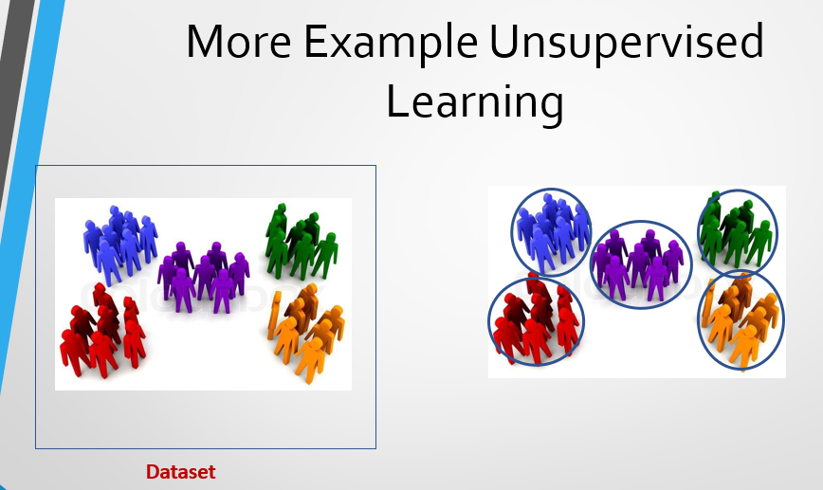

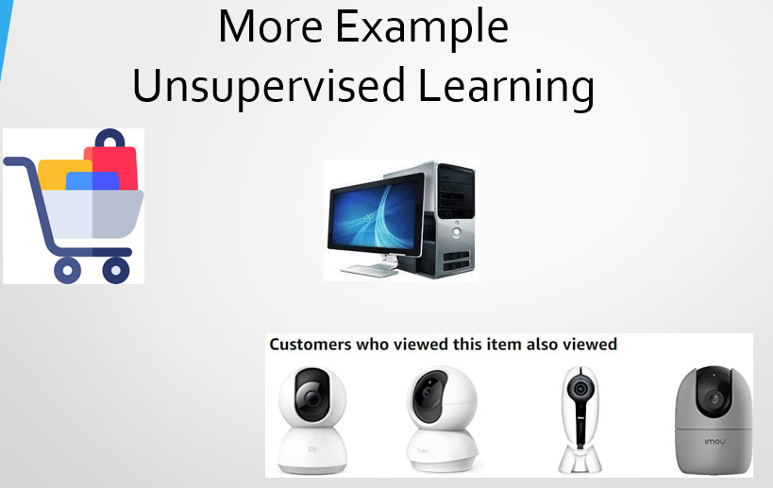
Example of unsupervised learning
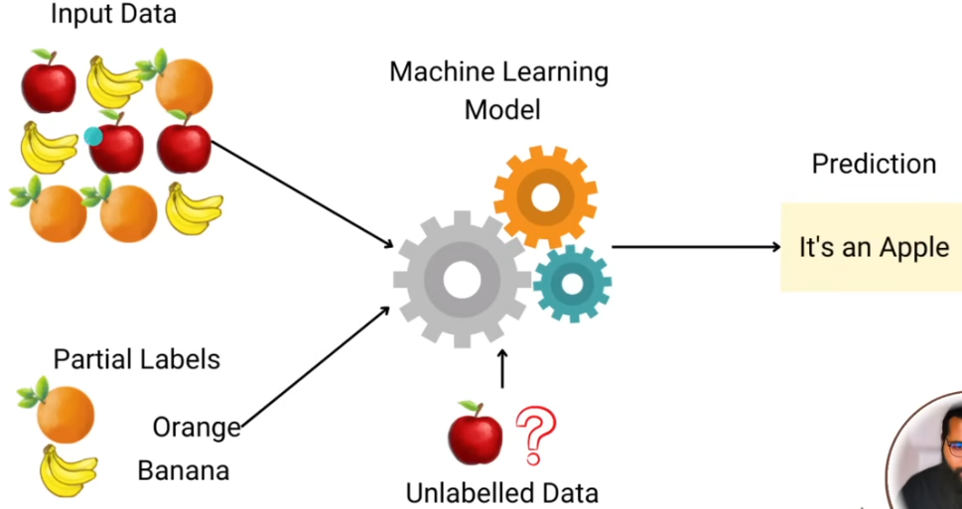
Note: - We have given data (without label) like apple and oranges to algorithm and based on shapes of oranges and banana it creates groups and when we assign label to that group then algorithm will not tell us that its apple or oranges rather it tells us that it is near to this group so it may be belonged to that group.
Reinforcement Learning
Reinforcement Learning is a type of machine learning where an agent learns by interacting with its environment and getting rewards or penalties based on its actions.
The goal is to learn which actions give the best rewards over time. It is also known as learning from trials and errors
Example:
A robot learns to walk by trying different movements — when it moves correctly, it gets a reward; when it falls, it gets a penalty.
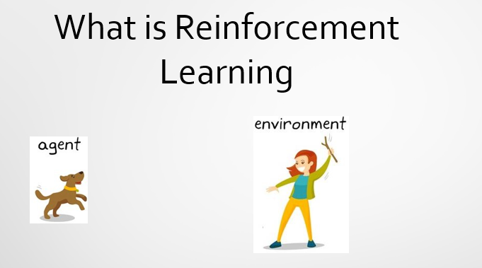
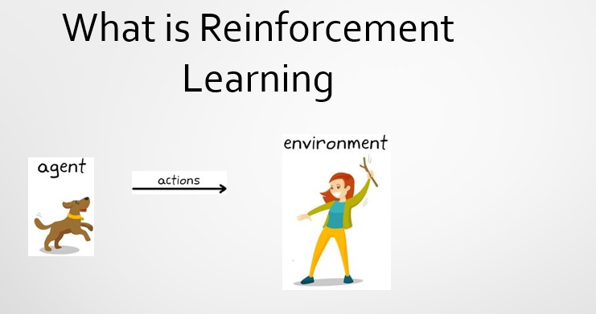
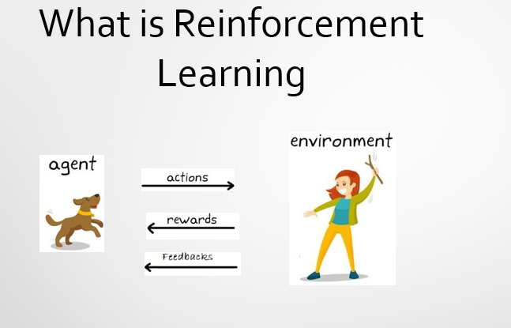
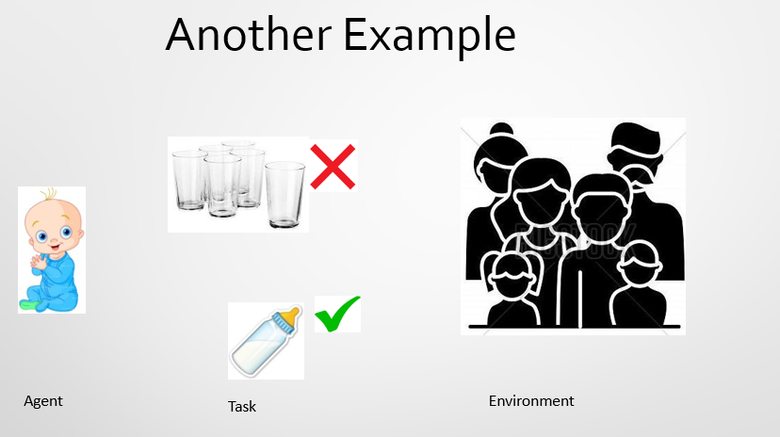
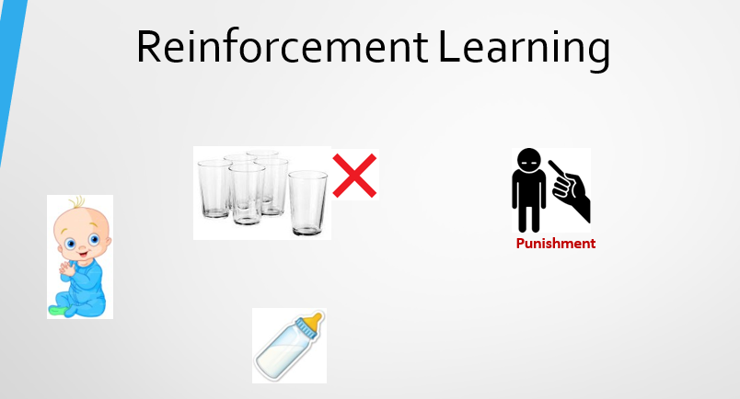
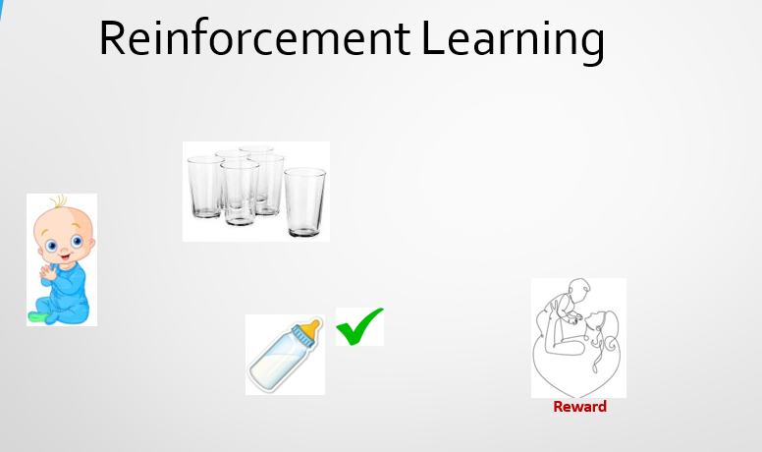
Lecture 03
What is Data Preprocessing?
Data preprocessing means cleaning and preparing your raw data so that it becomes ready for a machine learning model to understand and learn from.
Data Quality
Good data should be accurate, complete, and consistent. Poor-quality data can lead to wrong results or poor model performance.
Major Tasks in Data Preprocessing
There are several main steps to make data useful:
- Data Cleaning – Fixing missing values, removing errors, and correcting wrong or duplicate data.
Example: Filling empty “age” fields or removing repeated entries.
- Data Integration – Combining data from different sources into one dataset.
Example: Merging customer data from sales and support departments.
- Data Reduction – Making the dataset smaller but keeping important information.
Example: Removing unnecessary columns or summarizing data to speed up processing.
Data Quality: Why Preprocess the Data?
We preprocess data to make sure it is high-quality, because bad or messy data can lead to wrong results. Good data should be accurate, complete, and easy to understand.
Here are the main measures of data quality in simple words:
- Accuracy: Is the data correct, or does it contain mistakes?
Example: If someone’s age is written as 250, it’s inaccurate.
- Completeness: Is any data missing or not recorded?
Example: Some customers may not have their phone numbers saved.
- Consistency: Is the same data the same everywhere?
Example: A customer’s address is updated in one file but not in another.
- Timeliness: Is the data updated on time?
Example: Using last year’s prices instead of current ones is untimely.
- Believability: Can we trust the data to be true?
Example: Data from an unknown source might not be reliable.
- Interpretability: Is the data easy to read and understand?
Example: Using clear labels like “Customer Name” instead of random codes.
Major Tasks in Data Preprocessing
Before using data in machine learning, it must be cleaned, combined, and simplified. These main tasks make the data accurate, consistent, and easier to use.
1. Data Cleaning
This step fixes problems in the data. It involves:
- Filling in missing values (e.g., replacing empty cells with averages)
- Smoothing noisy data (removing random errors or variations)
- Identifying or removing outliers (unusual values that don’t fit)
- Resolving inconsistencies (making data uniform across sources)
Example: If some prices are missing or written wrongly, they are corrected or filled in.
2. Data Integration
This means combining data from different sources like databases, files, or data cubes into a single dataset.
Example: Merging customer data from sales and support systems.
3. Data Reduction
- This step makes data smaller and simpler without losing key information. It includes:
- Dimensionality reduction: Removing unnecessary attributes or columns.
- Numerosity reduction: Replacing large datasets with smaller summaries.
- Data compression: Storing data in a compact form to save space.
- Example: Keeping only important features like “Age” and “Salary” instead of 50 columns of details.
Data Cleaning
Data cleaning is the process of fixing problems in raw data to make it accurate, complete, and consistent before analysis.
In the real world, data is often dirty, meaning it contains mistakes or missing information due to human or system errors.
1. Incomplete Data
When some information or attribute values are missing or not recorded.
Example: Occupation = “ ” (blank or missing data).
2. Noisy Data
When data contains random errors, outliers, or wrong values.
Example: Salary = “−10” (which is clearly an error).
3. Inconsistent Data
When data does not match or agree across records or uses different formats.
Example: Age = “42” but Birthday = “03/07/2010” (conflict).
Example: Old rating system was “1, 2, 3,” now it’s “A, B, C.”
4. Intentional Errors
Sometimes people intentionally enter false or disguised data.
Example: Using “Jan 1” as a fake birthday for privacy reasons.
Incomplete (Missing) Data
Sometimes, data is not fully available — some values are missing or not recorded for certain attributes.
Example: In a sales dataset, a customer’s income might be blank because it was never entered.
Causes of Missing Data
- Equipment Malfunction – The device or software collecting data might fail.
Example: A sensor stops recording temperature halfway.
- Inconsistent Data Deleted – Data that doesn’t match other records may be removed.
Example: A record showing negative age is deleted for being invalid.
- Human Error or Misunderstanding – Data entry staff may forget or skip some fields.
Example: A worker forgets to enter a customer’s contact number.
- Unimportant at the Time – Some data might not seem useful when first collected.
Example: Birth date wasn’t asked because it wasn’t needed initially.
- No Historical Records – Older data or changes might never have been saved.
Example: A customer’s previous address history is missing.
How to Handle Missing Data
When some data values are missing, we need to fill or fix them so the dataset stays complete and useful for analysis.
There are a few common ways to handle missing data

1. Fill in Manually
You can enter the missing values yourself, but this is time-consuming and impractical for large datasets.
Example: Manually checking and entering each customer’s missing phone number.
2. Fill in Automatically
Automatic methods are faster and often used in machine learning:
- Using a Global Constant:
Replace missing values with a word like “Unknown” or “Not Available.”
Example: If income is missing, write “Unknown.”
- Using the Attribute Mean:
Replace missing values with the average of that attribute.
Example: If most customers have an income of 60,000, fill missing values with 60,000.
- Using the Class Mean:
Replace missing values with the average value from the same class or group, which is a smarter approach.
Example: If male customers have an average income of 70,000 and females 50,000, fill missing values accordingly.
Noisy Data
Noisy data means data that contains random errors or variations that make it inaccurate or unreliable. It can happen for many technical or human reasons.

Causes of Noisy Data
- Faulty Data Collection Instruments – Broken or inaccurate sensors and tools can record wrong values.
Example: A thermometer showing 200°C instead of 20°C.
- Data Entry Problems – Typing mistakes or wrong inputs by humans.
Example: Entering “50000” instead of “5000.”
- Data Transmission Problems – Errors while sending or transferring data.
Example: Internet issues causing missing or scrambled information.
- Technology Limitations – Devices or systems may not record values precisely.
Example: An old GPS giving slightly wrong coordinates.
- Inconsistency in Naming Conventions – Different spellings or formats for the same item.
Example: Writing “USA,” “U.S.,” and “United States” for the same country.
Other Data Problems Requiring Cleaning
Besides noise, data may also have:
- Duplicate records – Same entry repeated twice.
- Incomplete data – Missing values.
- Inconsistent data – Conflicting or mismatched information

How to Handle Noisy Data
Noisy data can lead to wrong analysis or poor model performance. To handle it, we use different techniques to smooth, detect, or remove the unwanted noise.
1. Regression
- Use regression methods to smooth the data by fitting it into regression function (like a line or curve).
- This helps identify the general trend and reduce random fluctuations.
Example: Using a line of best fit to smooth temperature readings over time.
2. Clustering
- Group (cluster) similar data points together.
- Data points that don’t fit into any cluster are considered outliers or noisy data, which can then be removed.
Example: In customer data, if one record is far away from others, it may be incorrect.
3. Combined Computer and Human Inspection
- Use computer programs to detect suspicious or unusual values.
- Then, have humans verify or correct them.
Example: A computer flags a salary value “10,000,000” as suspicious, and a human confirms if it’s an error.
Data Integration
Data integration is the process of combining data from multiple sources (like databases, files, or data warehouses) into a single, unified view for easier analysis and consistency.
1. Schema Integration
It means matching and merging data structures (schemas) from different sources.
Ensures that attributes referring to the same concept are treated as one.
Example: A.cust-id in one database may represent the same thing as B.cust-# in another — both mean Customer ID.
2. Metadata Integration
Metadata means “data about data” — it tells details like the name of a column, its data type, and format.
When combining data from different sources, their metadata may not match. So, we need to make them the same for consistency.
Example:
If one file saves dates as DD/MM/YYYY and another saves them as MM-DD-YYYY, we should change both to the same format before combining.
Handling Redundancy in Data Integration
Sometimes when combining data from many databases, the same information appears more than once — this is called redundant data.
Object identification: The same thing may have different names in different databases.
Example: One database has Customer ID, and another has Cust No, but both mean the same thing.
By carefully merging data and removing duplicates, we can:
- Avoid repeated or conflicting information,
- Speed up data processing, and
- Improve the quality of data analysis.
Data Reduction Strategies
Data reduction means making the dataset smaller while keeping it useful for analysis.
Why it’s needed:
Databases can be very large (terabytes of data). Analyzing all of it takes a lot of time and memory. Reducing data size helps speed up analysis.
How it’s done:
Dimensionality reduction: Remove unnecessary or less important columns/attributes that don’t affect results much.
Example:
If a dataset has 50 features, but only 10 are useful for predictions, keep those 10 and remove the rest to make data processing faster.
Dimensionality Reduction
Curse of Dimensionality
When the number of features or columns in a dataset increases, the data becomes very spread out and harder to understand. This makes it difficult for algorithms to find patterns, clusters, or outliers because the distance between points no longer has clear meaning. Also, as more features are added, the number of possible combinations grows very quickly, which makes the analysis slow and confusing.
Example
Imagine you are studying students’ performance using 2 features — “Study Hours” and “Attendance.” It’s easy to visualize and find patterns in a 2D graph.
Now, if you add 50 more features like “Sleep Hours,” “social media Time,” “Snack Type,” etc., the data becomes very high-dimensional. The points spread out so much that finding which students are similar or different becomes hard.
Why It’s a Problem
In high dimensions, the data looks empty or sparse, and algorithms that depend on distances, like clustering or nearest neighbor, stop working well. It also increases the time and space needed to process the data.
Dimensionality Reduction (The Solution)
To solve this problem, we reduce the number of features by removing unimportant or repetitive ones. This helps remove noise, saves storage space, and speeds up the analysis. It also makes it easier to see and understand the data using visual graphs.
Example:
If a dataset has 100 features but only 10 are useful, keeping just those 10 makes the data easier to work with and understand while still giving similar results.
Lecture 4
Feature engineering
Feature engineering
Feature engineering in machine learning means choosing, changing, or making new features (data columns) from the raw data so that the model can learn better and give more accurate results.
Example:
- Creating a new column “Age” from “Date of Birth”
- Converting text like “Yes/No” into numbers (1/0)
- Combining two columns (e.g., “Height” and “Weight” → “BMI”)
Importance of Feature Engineering
- Enhances model accuracy:
Creating meaningful features helps the model learn better.
Example: Calculating “Age” from “Date of Birth” makes predictions (like loan approval) more accurate.
- Reduces overfitting and underfitting:
Choosing only useful features keeps the model balanced.
Example: Removing irrelevant features like “Name” or “ID” prevents overfitting in a student score prediction model.
- Helps models generalize better:
Well-engineered features make the model perform well on new data.
Example: Normalizing “Income” values ensures the model works properly for people from different countries.
- Essential for handling real-world data:
Real data is messy and incomplete, so it must be cleaned and transformed.
Example: Filling missing values in “Age” or converting “Yes/No” to 1 and 0 helps models understand the data.
Common Techniques
1. Handling Missing Values
Filling in or removing empty data so the model can learn properly.
Example: If some people’s “Age” is missing, you can fill it with the average age or remove that row.

2. Creating New Features
Making new useful columns from existing data to help the model learn better.
Example: From “Date of Birth,” create a new feature “Age.”
3. Dimensionality Reduction
Reducing the number of features (columns) while keeping the most important information.
Example: If you have 100 features, use techniques like PCA to reduce them to 10 important ones.
4. Feature Selection
It means picking only the most useful features from the dataset to make the model simpler, faster, and more accurate.
This helps reduce model complexity and training time.
5. Feature Extraction
Creating new features by combining or transforming old ones.
Example: From an image, extracting edges, colors, or shapes that represent it better for the model.
Creating New Features
Feature Creation:
It means making new features by combining existing ones to give the model more useful information.
Example: Create BMI from height and weight or make apartment area from length × breadth.
Feature Splitting:
It means breaking one feature into smaller, more helpful parts so the model can understand it better.
Example: Split a datetime column into separate day, month, and year features.
Dimensionality Reduction
Reducing the number of features (columns) while keeping the most important information.
Example: If you have 100 features, use techniques like PCA to reduce them to 10 important ones. to make the model faster and easier to understand.
There are two main ways to do this:
- Feature Selection:
It means picking only the most useful features from the dataset to make the model simpler, faster, and more accurate.
This helps reduce model complexity and training time.
Choose only the most important features from the original data.
Example: Keep only “Age” and “Income” for prediction and remove less useful ones.
- Feature Extraction:
It means creating new features by transforming existing data into a smaller and more meaningful form.
In simple terms, it helps reduce data size while keeping the important information.
Example: Use techniques like PCA to combine many features into a few key ones.
Feature Selection
It means picking only the most useful features from the dataset to make the model simpler, faster, and more accurate.
This helps reduce model complexity and training time.
Filter Methods:
These methods use statistical tests (like correlation or chi-squared tests) to rank features based on how important they are for the target output.
They are fast and easy to use, but they don’t check how features interact or work together in the model.
Example:
If we want to predict “Student Performance,” we might use correlation to see which features (like Study Hours or Attendance) are most related to performance and select those.
Feature Extraction:
It means creating new features by transforming existing data into a smaller and more meaningful form.
In simple terms, it helps reduce data size while keeping the important information.
Feature Extraction in Different Fields:
- Image Processing / Computer Vision:
Turns raw pixel data into useful patterns like edges, corners, or shapes, which help the model recognize objects.
Example: Detecting the shape of a car in an image.
- Natural Language Processing (NLP):
Converts text into numeric data that a model can understand, such as Bag of Words or Word2Vec.
Example: Changing sentences into word vectors so the model can understand meaning and relationships between words.
Bag of Words (BoW):
Turns text into numbers by counting how often each word appears.
Example: “I love apples” → [1, 1, 1, 0]
Word2Vec:
Turns words into numbers that capture meaning and relationships between words.
Example: “King” and “Queen” have similar vectors because their meanings are related.
Data Preprocessing and Feature Engineering
Data Preprocessing:
It means cleaning, fixing, and organizing raw data so it becomes correct, complete, and ready for use in a model.
Example: Removing missing values, handling duplicates, or converting text to numbers.
Feature Engineering:
It means creating or improving features from existing data to help the model learn better and make accurate predictions.
Example: Creating a new feature like “Age” from “Date of Birth.”
Conclusion
Feature engineering plays a key role in building strong and accurate machine learning models.
It helps turn raw data into meaningful information, improving both model performance and understanding.
A good feature can sometimes outweigh complex models.

Lecture 5
Supervised Machine Learning Algorithms
Decision Tree
A Decision Tree is a supervised learning algorithm used for both classification (categorizing data) and regression (predicting numbers).
It works like a flowchart:
- Each node shows a feature (like Age or Salary).
- Each branch shows a decision rule (like Age > 18).
- Each leaf node gives the final result (a class or a value).
Example:
If Age > 18 → “Adult”
Else → “Child”
Decision Tree Representation
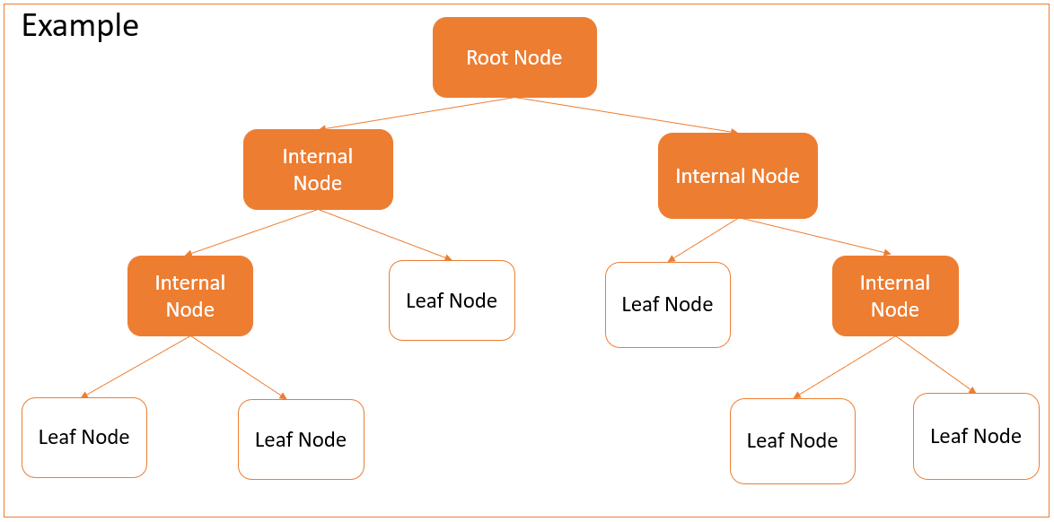

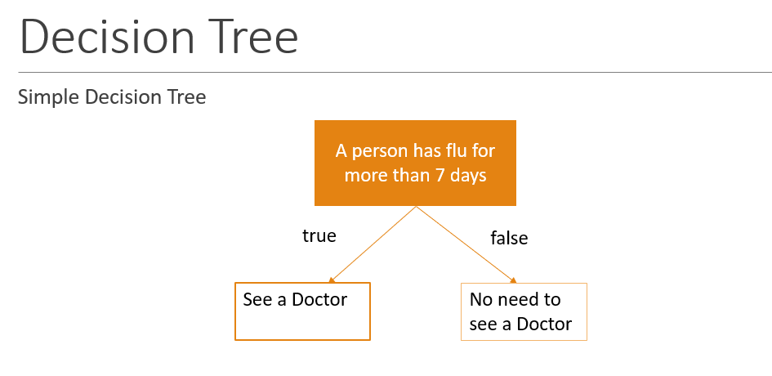
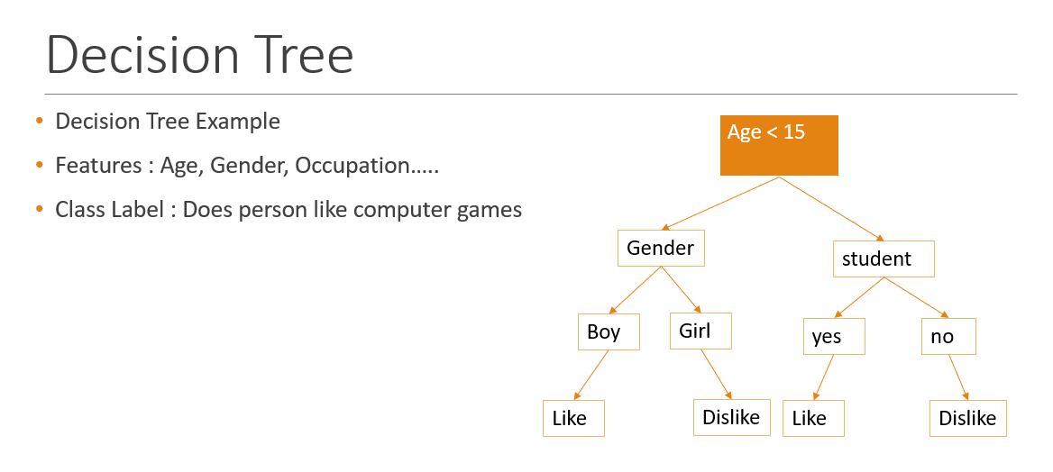
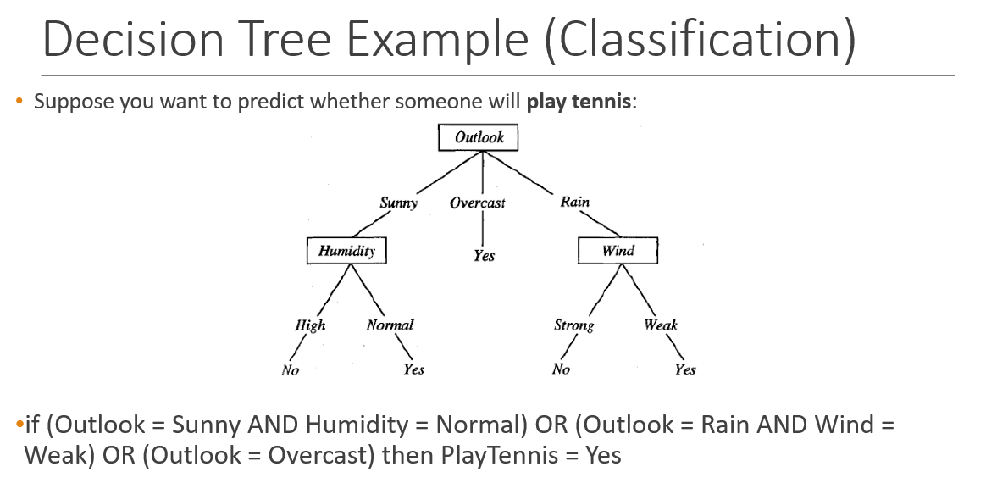
Basic Decision Tree Learning Algorithm:
- First, the best feature is chosen to be the root node of the tree.
- Each feature is checked using a statistical test to see how well it divides the data into correct groups.
- The same process is repeated for every branch — choosing the best feature at each step.
- These steps continue until all branches end with leaf nodes (final results).
Types of Decision Tree
Univariate Decision Trees:
A univariate decision tree makes each split using only one feature at a time.
- Example: If Age < 30, go left; otherwise, go right.
These are the most used decision trees in machine learning because they are simple and easy to understand.
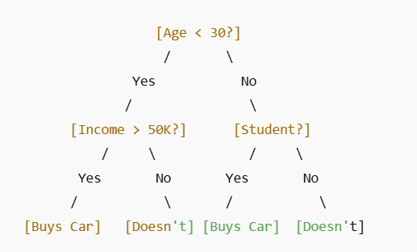
Multivariate Decision Tree
In this type of tree, each decision (split) can depend on more than one feature at the same time — like Age and Income together instead of just one.
Example Decision Rule:
- 2 × Age + 3 × Income < 50
This allows the tree to capture more complex decision boundaries.
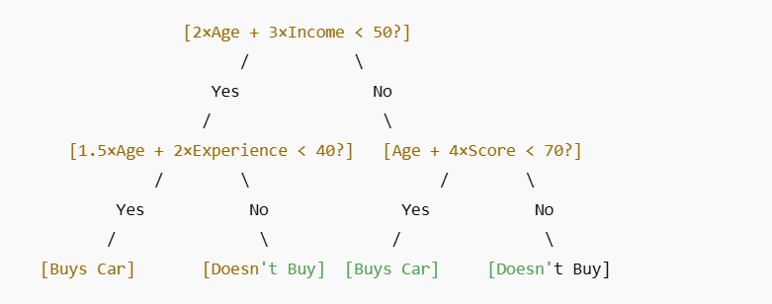
Classification Trees:
A classification tree is used when the target output is categorical — meaning it has distinct groups or labels (like Yes/No, Spam/Not Spam).
The goal is to classify each data point into one of these categories.
Example:
Predicting whether a customer will buy a product or not buy.
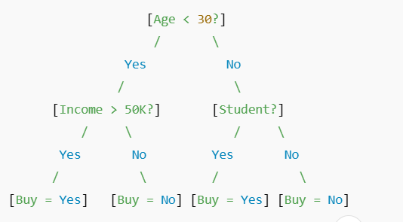
Regression Trees:
A regression tree is used when the target value is continuous — meaning it’s a number (like price, temperature, or sales).
Instead of predicting categories, it predicts numeric values.
Each leaf node gives a number, usually the average of all data points that reach that leaf.
Example:
Predicting the price of a house based on size, location, and number of rooms.
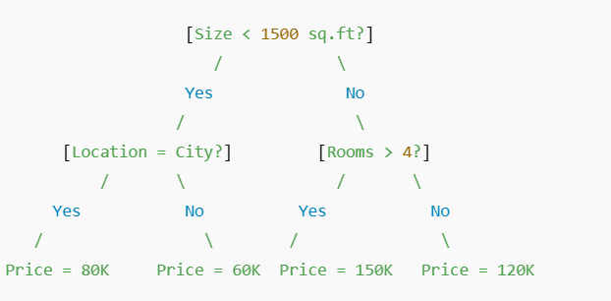
Real-World Uses of Decision Trees
Netflix
Netflix uses decision trees to suggest movies and shows that match what you like to watch.
Example: If you often watch action movies, Netflix may show you films like Mission Impossible or Extraction.
Uber
Uber uses decision trees to set ride prices and understand driver or rider behavior.
Example: If it’s rush hour and many people want rides, the system increases prices to keep rides available.
Airbnb
Airbnb uses decision trees to help hosts set the right price for their homes.
Example: If your home is in a busy area and has 2 bedrooms, the system may suggest a price like $100–$120 per night.
Google
Google uses decision trees for search results and fraud detection.
Example: If one ad gets too many fake clicks, the system marks it as suspicious or fake activity.
Microsoft
Microsoft uses decision trees in Azure Machine Learning to make predictions for businesses.
Example: A company can predict which customers might stop using their service so they can offer deals to keep them.

Lecture 6
Naïve Bayes
Naive Bayes
Naive Bayes is a machine learning algorithm that uses probabilities to make predictions.
It is based on a mathematical rule called Bayes’ Theorem.
Key Idea
It assumes that all features (inputs) are independent of each other —
that means each feature affects the result separately and doesn’t depend on others.
(This is why it’s called “naive” — because this assumption is often not fully true in real life.)
Example
If we are predicting whether an email is spam,
Naive Bayes looks at each word — like “free”, “win”, “offer” —
and calculates how likely it is that the email is spam based on those words.
Then it combines these probabilities to make a final prediction.
Why It’s Useful
Even though the “independence” assumption is simple,
Naive Bayes often gives very good results, especially for:
- Spam detection
- Sentiment analysis (positive or negative reviews)
- Document classification

Bayes Theorem
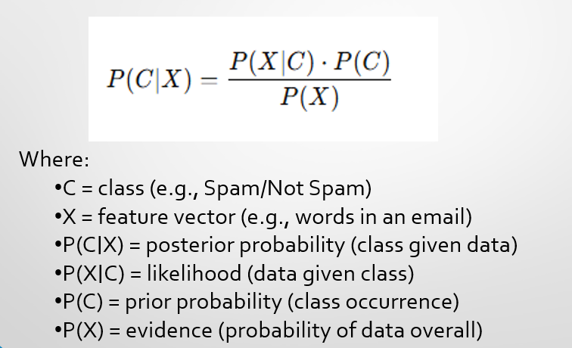
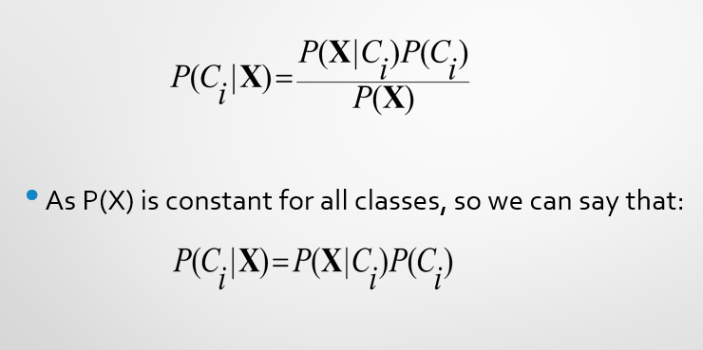

Naïve Bayes Classifier: Example
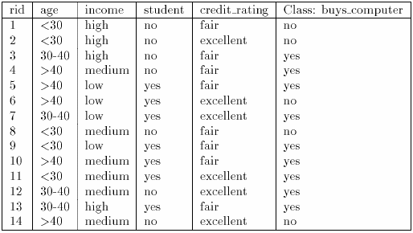
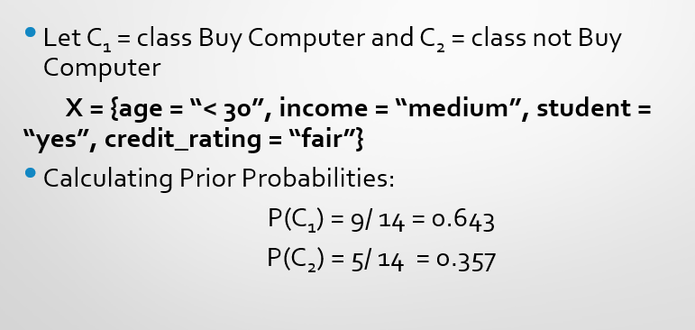

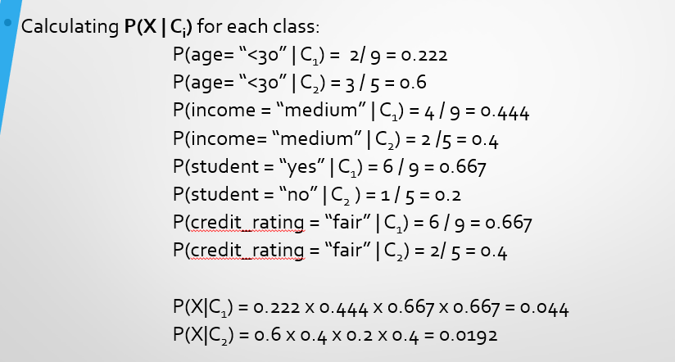
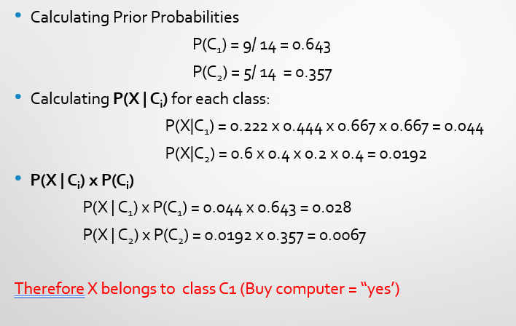

Example 2
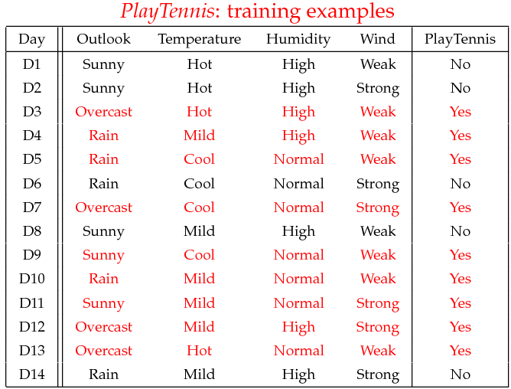
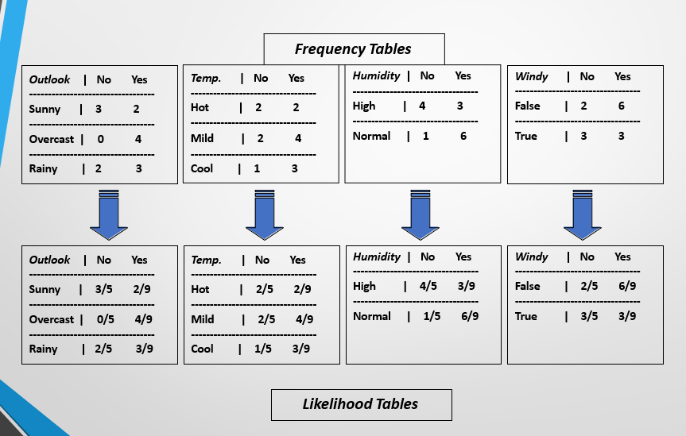

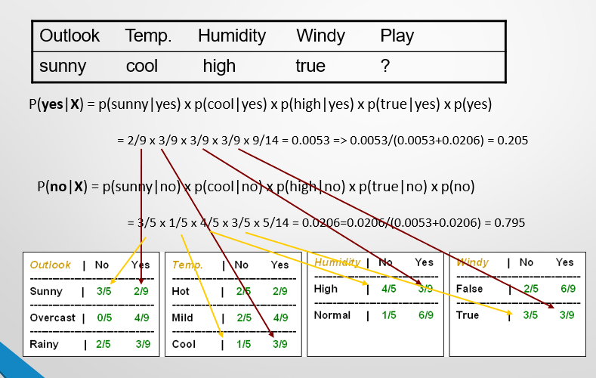
Example 3 (Assignment)
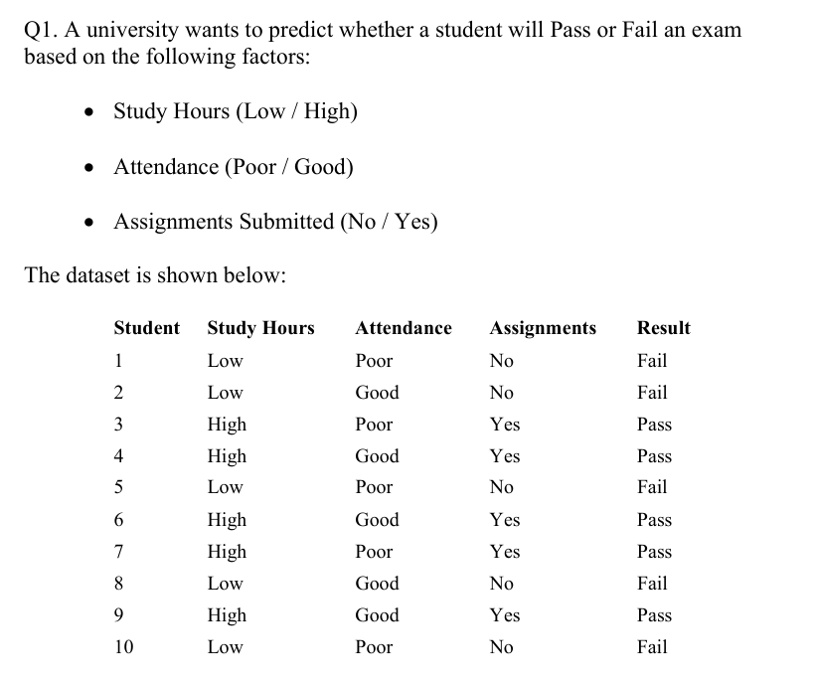
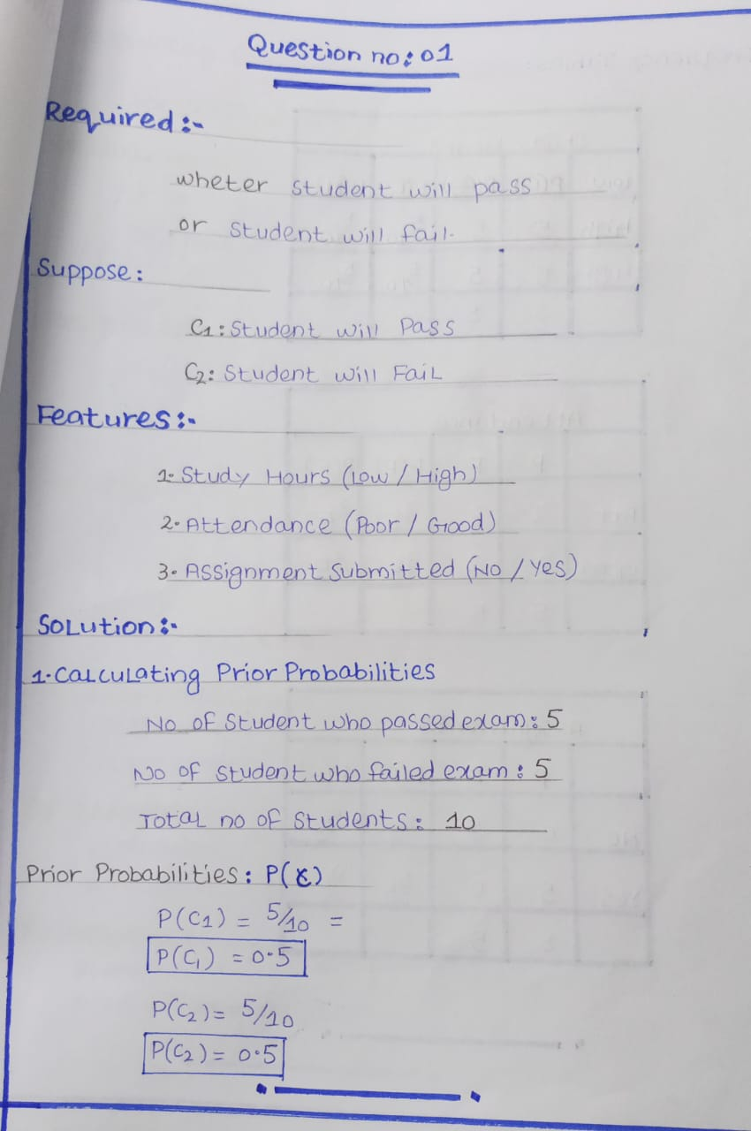
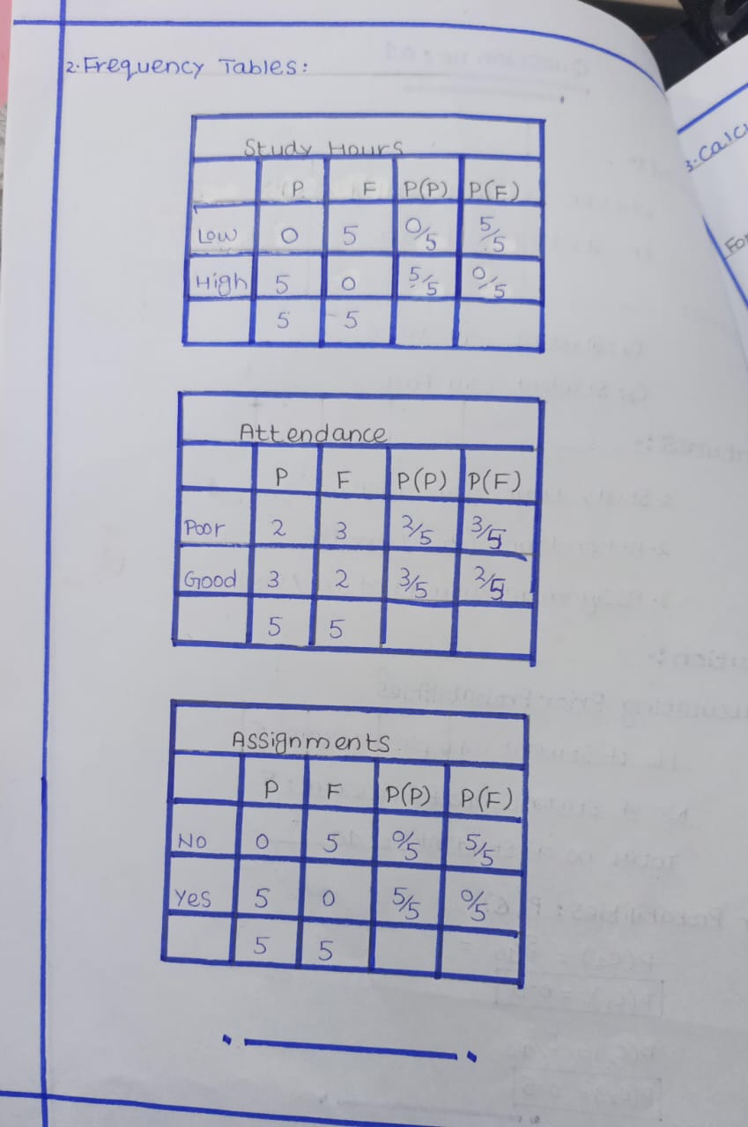
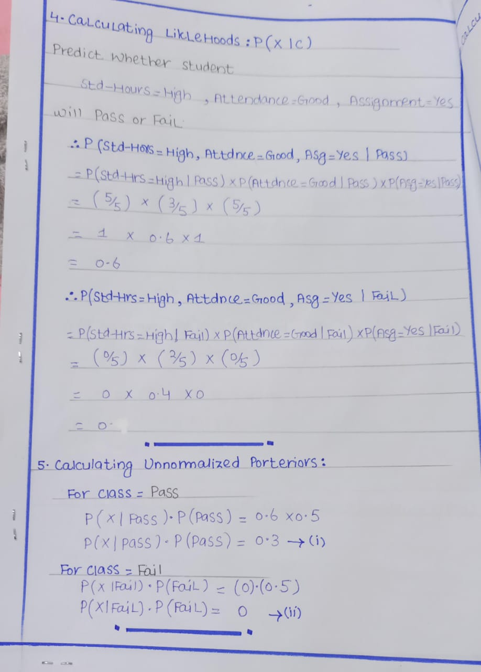
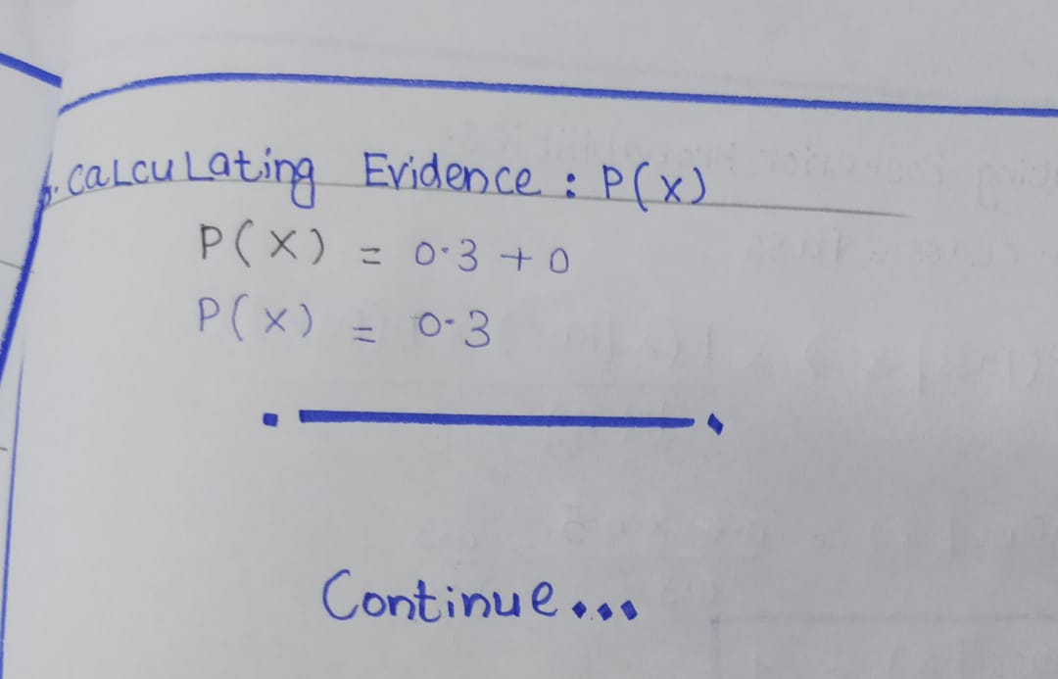
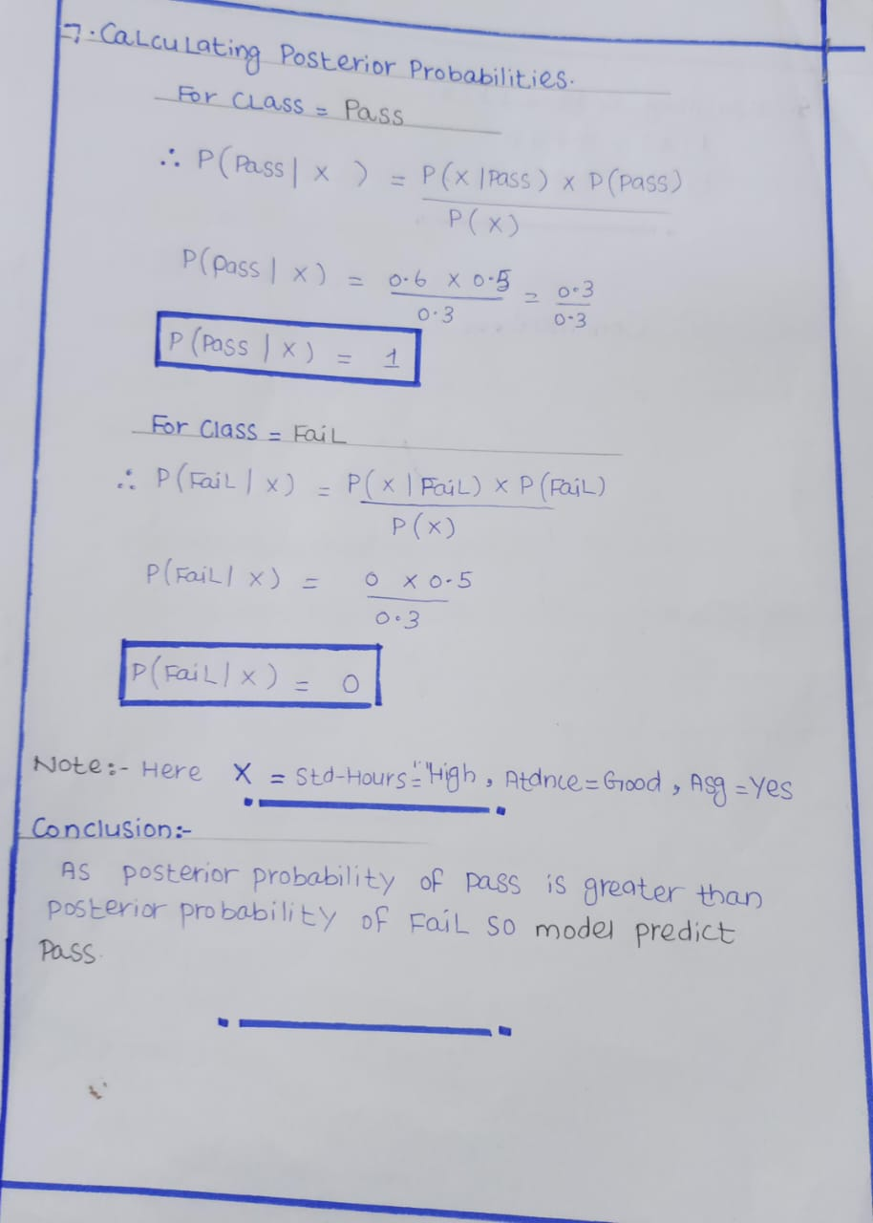

Lecture 7
K-Nearest Neighbors
K-Nearest Neighbors (KNN)
KNN is a supervised learning algorithm —
which means it learns from labeled data (data that already has answers).
It can be used for both classification (like yes/no, spam/not spam)
and regression (predicting numbers, like price or temperature).
How It Works
When a new data point comes in:
- KNN looks at the nearest data points (its neighbors) in the training set.
- It checks their labels (answers).
- Then it predicts the new point’s label based on what most of its neighbors are.
So basically,
“Show me your friends, and I’ll tell who you are.”
If most nearby points are “cats,” the new one is also likely a “cat.”
Key Idea
KNN works on the idea of feature similarity —
similar things (data points that are close together)
are likely to have similar outputs or labels.
Lazy Learning
- KNN is called a lazy learner because:
- It doesn’t do any heavy training before prediction.
- It just stores all the data,
and when asked to predict, it finds the nearest neighbors and decides then.
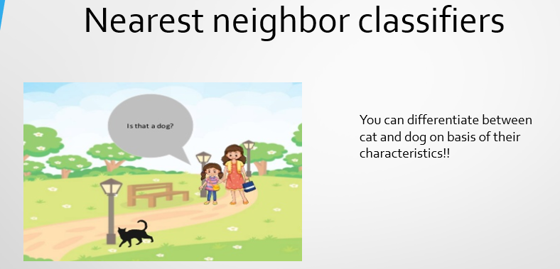
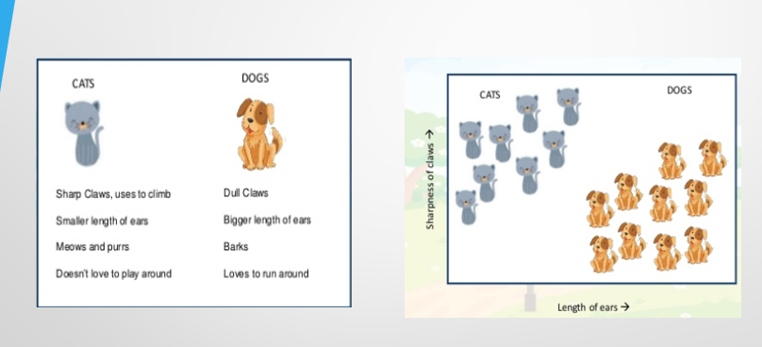

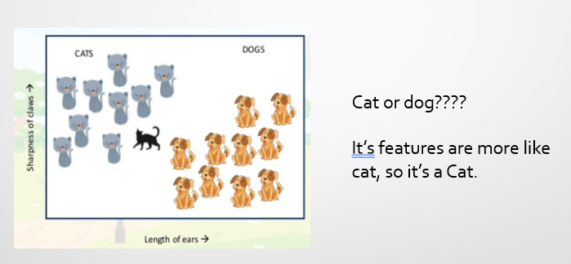
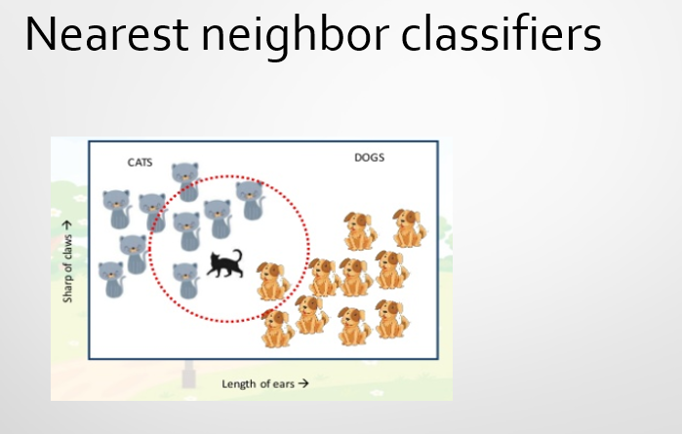
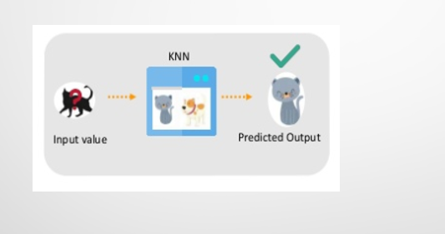
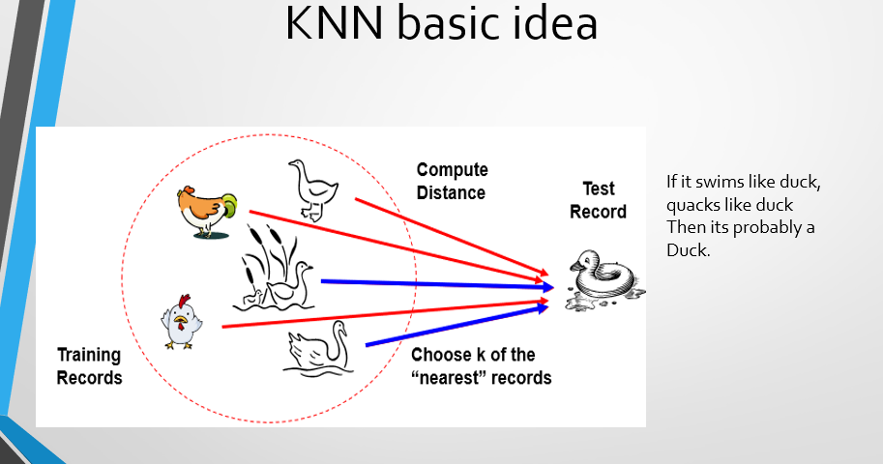
How KNN Works (Step by Step)
1. Choose k: the number of neighbors to consider (e.g., 3, 5, 7).
2. Calculate distance between the new point and all training points Commonly: Euclidean distance.
3. Pick the k nearest points (smallest distances).

4. Make a prediction:
- Classification: Majority voting (most common label among neighbors).
- Regression: Average of neighbors’ values.
Q: Why don’t we choose k = 1 or even numbers
- k = 1:
Too sensitive — model depends on just one neighbor,
so it overfits and reacts to noise or outliers.
- Even k (like 2, 4, 6):
Can cause ties in classification —
for example, 2 neighbors → 1 says “cat”, 1 says “dog” → no clear winner.
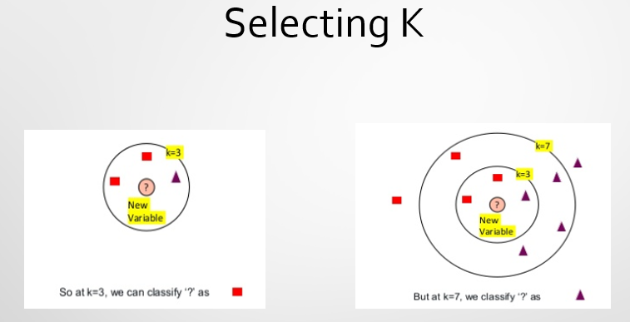
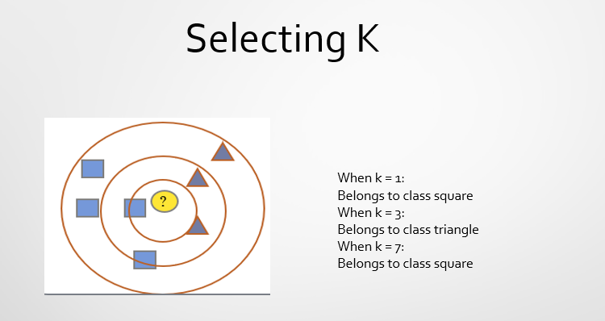
Choosing the Right K (in KNN)
There isn’t one fixed rule for picking the best K —
you usually find it by trying different values and seeing which works best.
Tips for Choosing K
- Small K values (like 1 or 2) →
Can make the model noisy and overfit (too sensitive to small changes).
- Large K values →
Make predictions more stable and less affected by noise,
but can also smooth out important details. (So the model misses that small local pattern —
it becomes too smooth and less precise.
- Trial and Error →
Try several K values and pick the one that gives the best accuracy.
- Rule of Thumb:
$$K=\sqrt{N}$$where N is the total number of training samples.
- Odd K values →
Use odd numbers (like 3, 5, 7…) to avoid ties between classes.
Distance Matrix
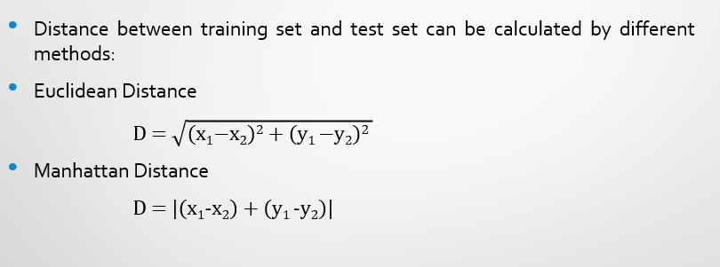
Example 1
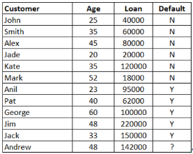
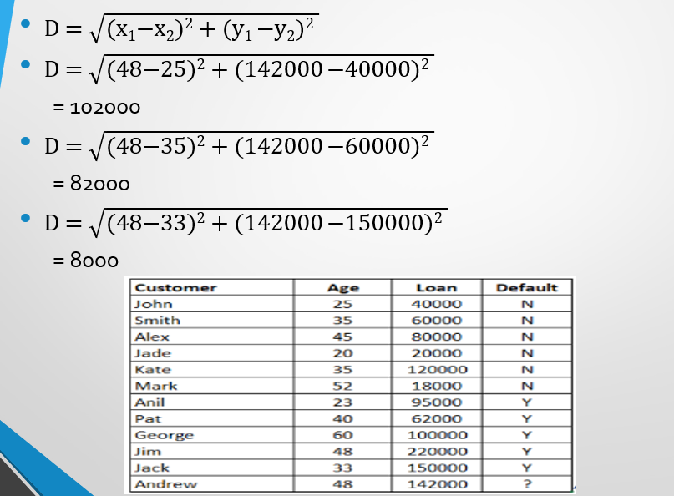
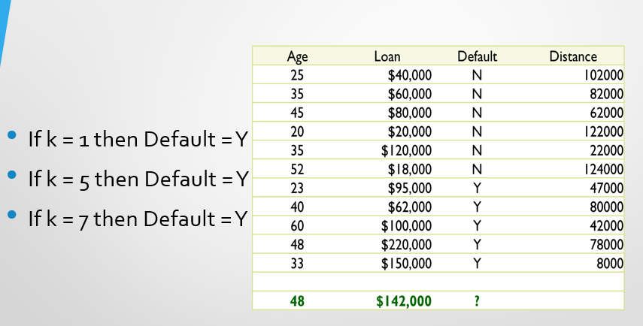

Example 2
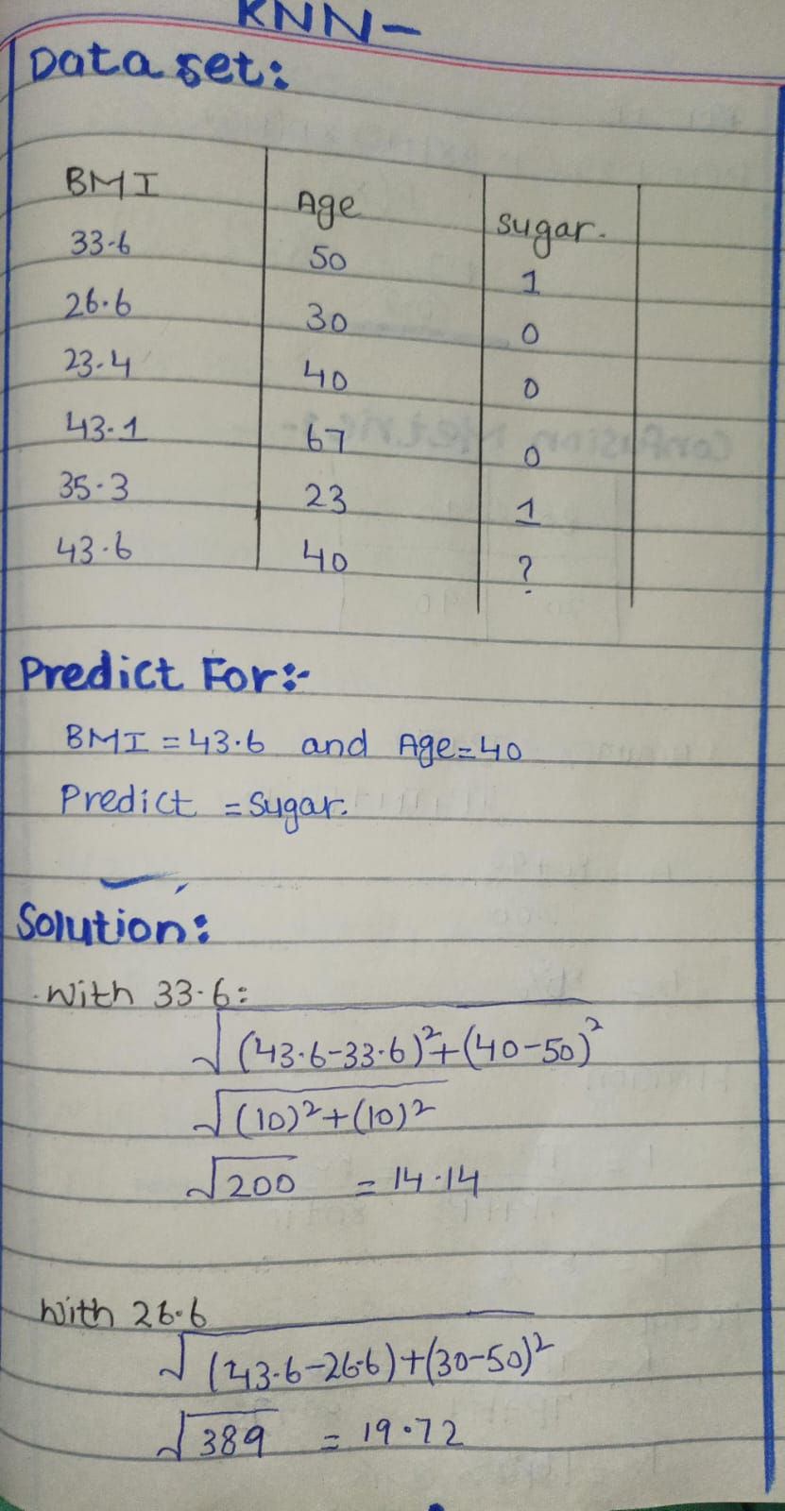
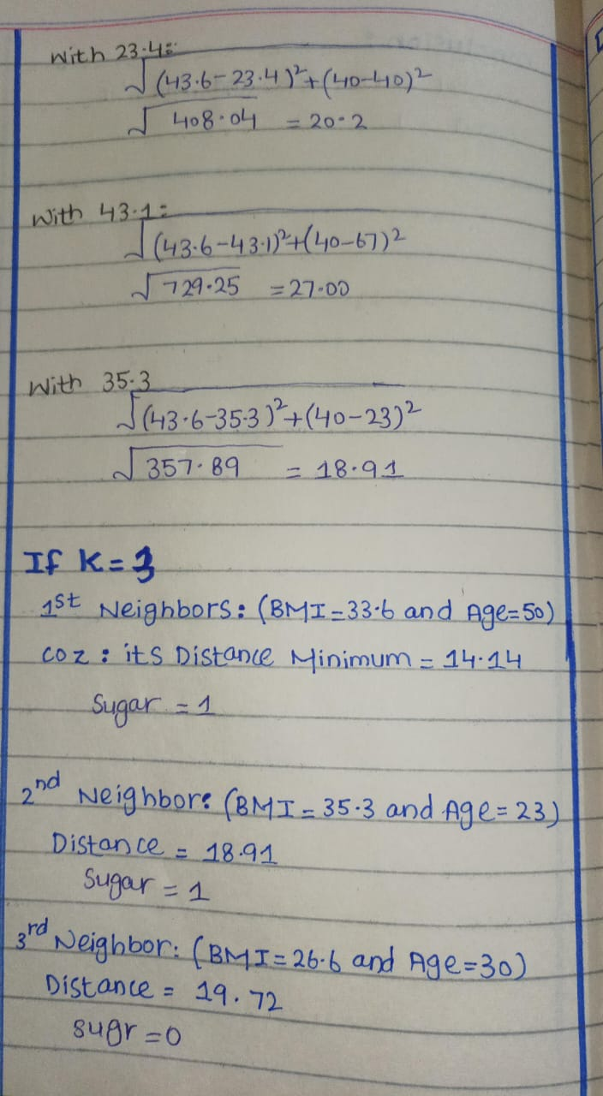
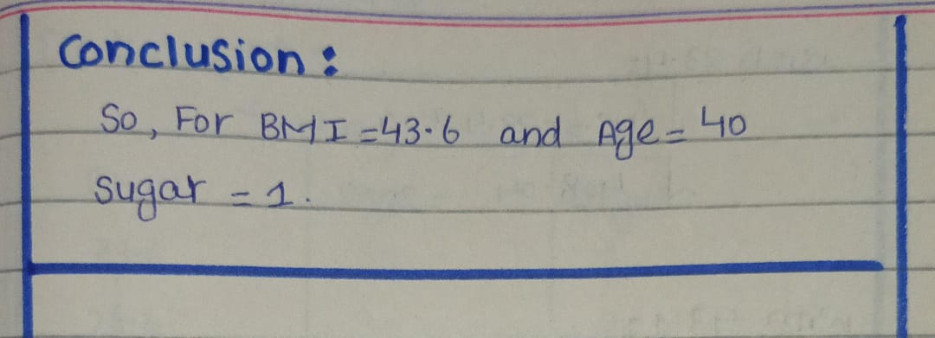
Lecture 9
ANN
ANN
Artificial Neural Networks (ANNs) are computer systems that work somewhat like the human brain.
They have layers of connected points called neurons, and each connection has a weight (a number) that changes as the network learns from data.
Structure of ANN
- Input Layer – Receives the raw data (features).
- Hidden Layers – Process data through weighted connections and activation functions.
- Output Layer – Produces the final prediction/classification/regression output.
Structure of ANN
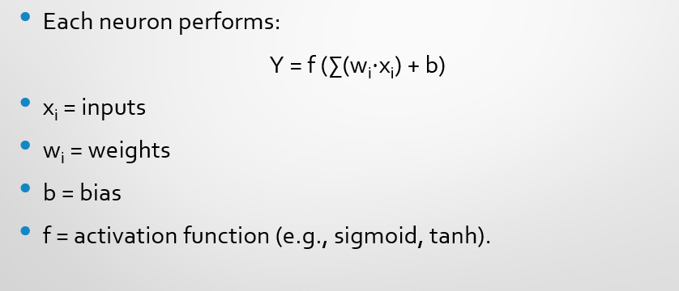

Working Principle
- Each neuron performs a weighted sum of inputs.
- Adds a bias term.
- Applies an activation function to introduce non-linearity
Activation Function
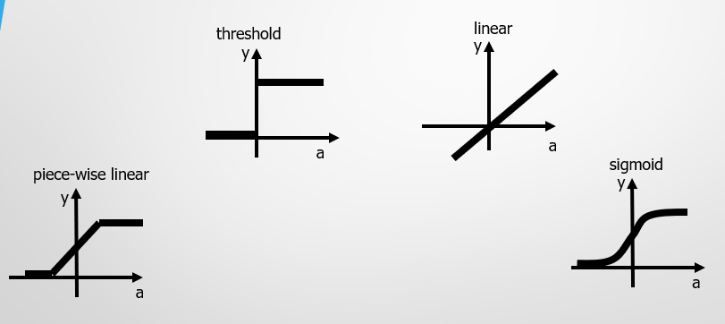
Threshold Logic Unit (TLU)
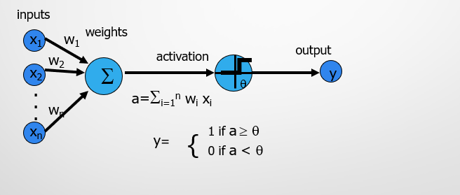

Key Features of Artificial Neural Networks (ANNs):
- Learning: ANNs learn by adjusting the strength (weights) of connections between neurons based on data.
- Non-linearity: Activation functions allow ANNs to understand and model complex patterns, not just straight-line relationships.
- Generalization: Once trained well, ANNs can make good predictions on new, unseen data, not just the data they learned from.
Bias
Bias in Artificial Neural Networks (ANNs):
A bias is an extra parameter in a neuron that the network can learn. It helps move (shift) the activation function left or right.
Why bias is important:
- Adds flexibility: Without bias, the activation function would always go through the origin (0,0), which limits what the neuron can learn.
- Shifts activation: Bias allows the neuron to “fire” even if all inputs are zero.
- Better learning: It helps the network learn more complex patterns and functions.
Bias
Why Bias is Useful:
Bias helps the network stay flexible when image conditions change — like lighting, angle, or position. This means the network can still recognize the object even if it looks a bit different.
Simple Analogy:
Think of a light switch with a dimmer knob:
- The weights decide how much the input (the switch position) affects the brightness.
- The bias is like the minimum brightness — even if the switch is turned very low, the light still glows a little because of the bias.
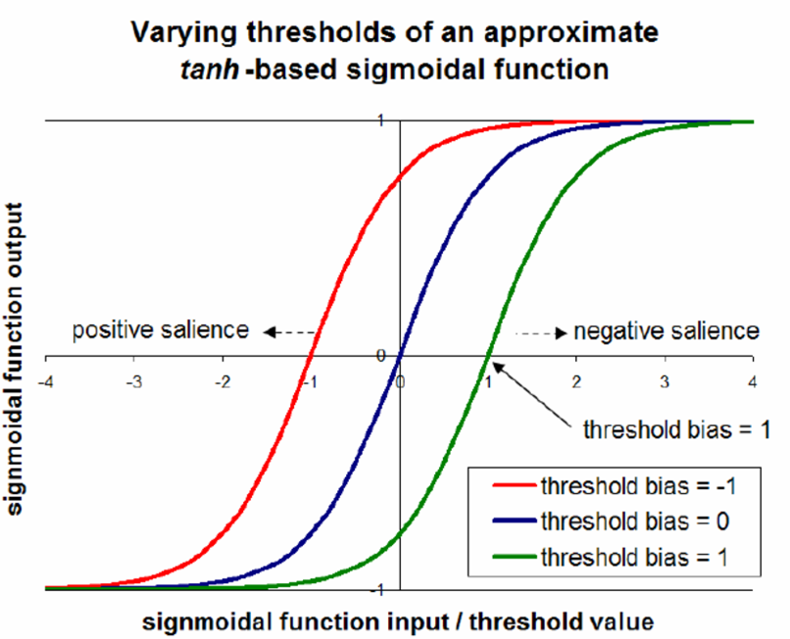
Types of ANNs
- Feedforward Neural Networks (FNNs):
Simple networks where information moves only forward. No loops.
Think of it like a water pipe: water flows one way only, from input to output. No loops, no going back.
- Convolutional Neural Networks (CNNs):
Great for images or data with spatial structure.
Can detect patterns like edges, shapes, or textures.
- Recurrent Neural Networks (RNNs):
Designed for sequences or time-based data (like text or stock prices).
Can remember previous inputs to influence current output.
Like reading a story: you remember the previous words to understand the next ones. Good for sequences.
- Deep Neural Networks (DNNs):
Have many hidden layers, allowing them to learn very complex patterns.
Architecture
Feed-forward Neural Networks
These are the nets in which the signals flow from the input units to the output units, in a forward direction.
They are further classified as:
- Single Layer Nets
- Multi-layer Nets
Recurrent Neural Networks (RNNs):
- RNNs are designed for sequences, like text, speech, or time series.
- They have loops inside the network, which let information from previous steps affect the current step.
- The signal does not physically go backward from output to input. Instead, the network remembers past inputs while processing the current input.
Single Layer Net
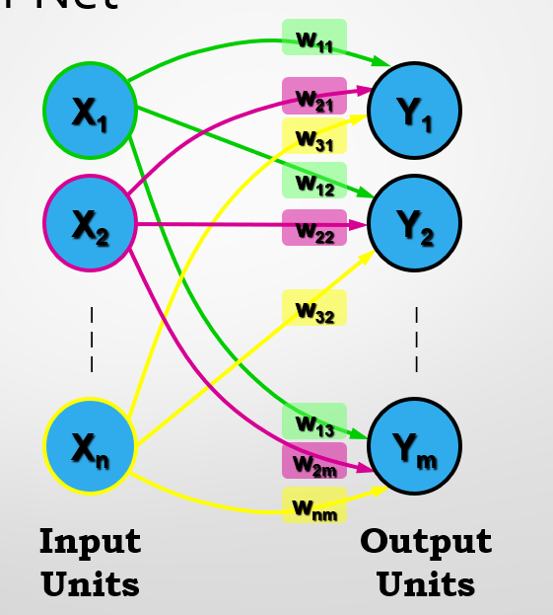

Multi-Layer Net
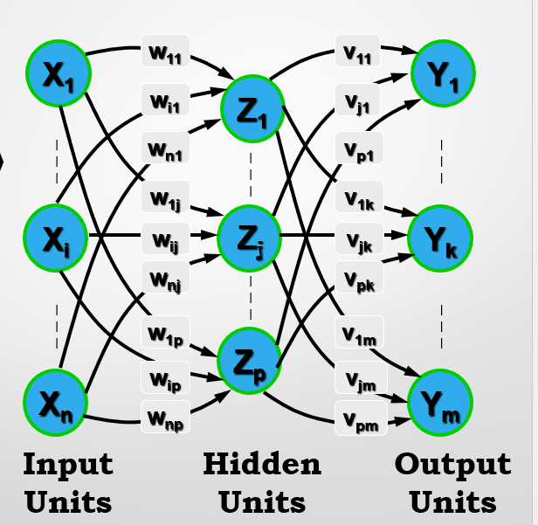

Recurrent Net
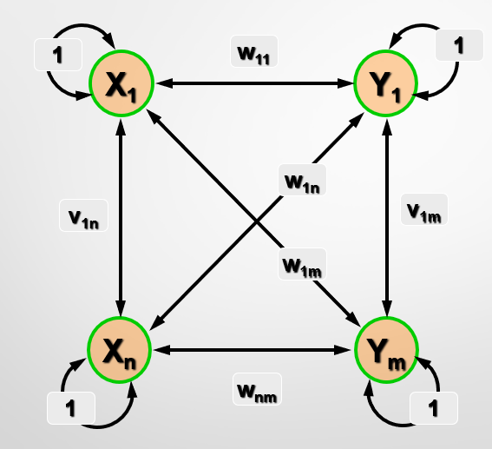
Applications of ANNs
- Image recognition (Face detection, Medical imaging).
- Natural Language Processing (Chatbots, Translation).
- Predictive analytics (Stock prices, Weather forecasting).
- Autonomous vehicles (object detection).

Advantages & Limitations
Advantages of ANNs:
- Can learn complex patterns: They can understand relationships that aren’t straight lines.
- High accuracy: Very good at recognizing patterns in images, text, or data.
Limitations of ANNs:
- Needs lots of data: Works best with large datasets.
- Computationally heavy: Training can take a lot of time and processing power.
- Black box problem: Hard to understand exactly how the network makes decisions

Lecture 10
Bias, Variance, Overfitting and Underfitting
Bias
Bias means the error caused when a model is too simple and doesn’t fully understand the real-world pattern in the data.
It shows how far the model’s average predictions are from the correct (true) values.
Simple Understanding
- High Bias: The model is too simple.
It doesn’t learn the details or patterns properly.
Example: Trying to fit a straight line to data that follows a curve.
The line misses the pattern → large error.
- Low Bias: The model is flexible and learns well.
It can follow the actual trend or shape in the data more accurately.
Everyday Example of Bias
Imagine you’re trying to guess someone’s age just by looking at their height.
You assume:
“Taller people are always older.”
That’s a simplified and wrong assumption, because height doesn’t always match age —
some kids can be tall, and some adults can be short.
So, your model (or assumption) would make the same kind of mistake again and again —
this is called high bias.
Variance
Variance means how much your model’s predictions change when you train it on different samples of the same data.
It shows how sensitive the model is to small changes in the training data.
Simple Understanding
- Low Variance → The model is stable.
Even if you train it on slightly different data, it gives almost the same results.
(Good — the model is consistent.)
- High Variance → The model is too sensitive.
Small changes in the data cause big changes in predictions.
(Bad — the model learns the “noise” instead of the real pattern.)
Bias & Variance
Bias vs Variance
Bias
Error that happens when the model is too simple.
It makes strong assumptions and misses real patterns in the data.
Example: Bigger houses are always more expensive.
→ The model underfits (can’t learn enough).
Variance
Error that happens when the model is too sensitive to the training data.
It learns even the tiny random details (noise) and changes a lot if the data changes.
Example: The model memorizes training data instead of understanding it.
The model overfits (learns too much detail).
Example of Bias
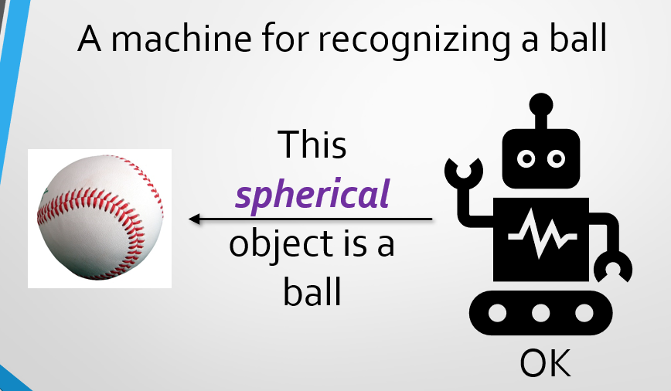
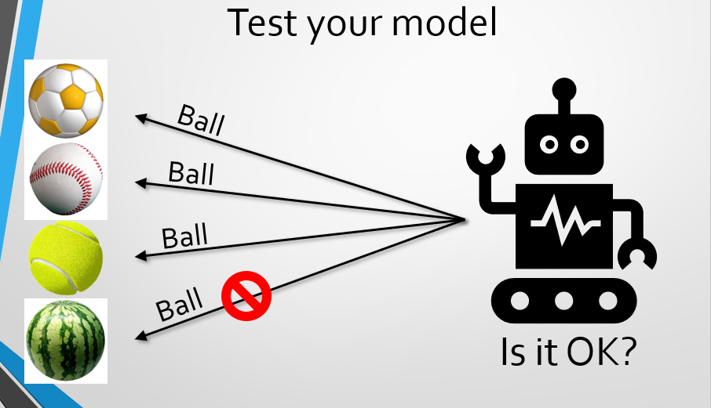
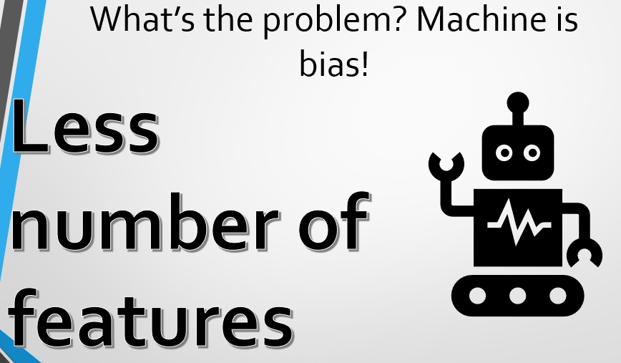
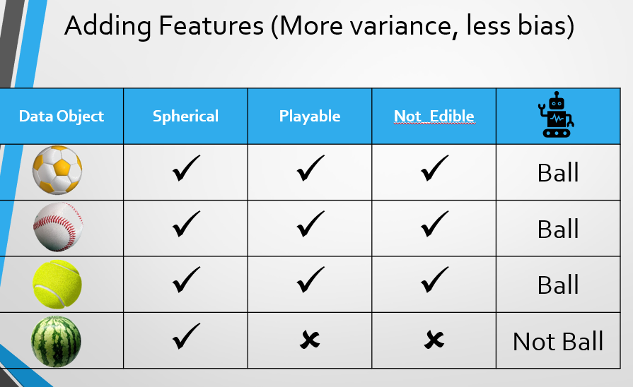

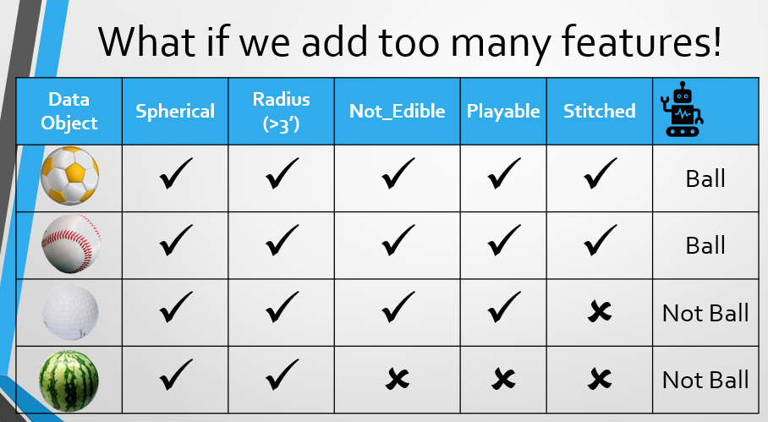
Underfitting
Underfitting happens when the model is too simple and can’t learn the real pattern in the data.
It doesn’t perform well — not even on the training data it learned from.
Example
Trying to draw a straight line through data points that clearly form a curve.
The line can’t follow the shape — it misses the pattern → that’s underfitting.
Causes
- The model is not complex enough (too few layers, neurons, or a simple algorithm).
- The model didn’t train long enough (too few training rounds or epochs).
- The features (data inputs) don’t give enough useful information.
Symptoms
- The model has high bias (it makes strong, oversimplified assumptions).
- It performs badly on both training and test data — meaning it didn’t even learn the training data properly.
Overfitting
Overfitting happens when the model is too complex and tries to learn everything,
including the tiny details and noise (random errors) in the training data.
It means the model learns too well — almost memorizing the training data —
so it performs great on training data but bad on new (test) data.
Example
Imagine you memorize all the answers to past exam questions.
You’ll do perfectly on that exam,
but when you face new questions, you’ll struggle — because you didn’t learn the real concept.
That’s overfitting.
Causes
- The model has too many parameters (too many layers or neurons).
- It’s trained for too many epochs (too long).
- There’s not enough data, so the model just memorizes instead of learning patterns.

Symptoms
- High variance → small changes in data cause big changes in results.
- Training errors are very low, but test errors are high.
- The model performs perfectly on data it saw before but fails on new data.
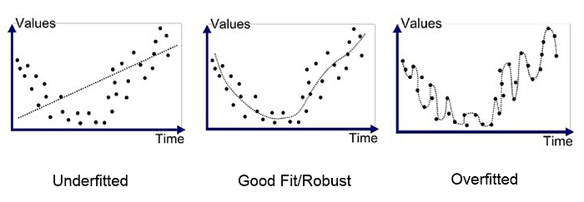
Bias and Variance Tradeoff
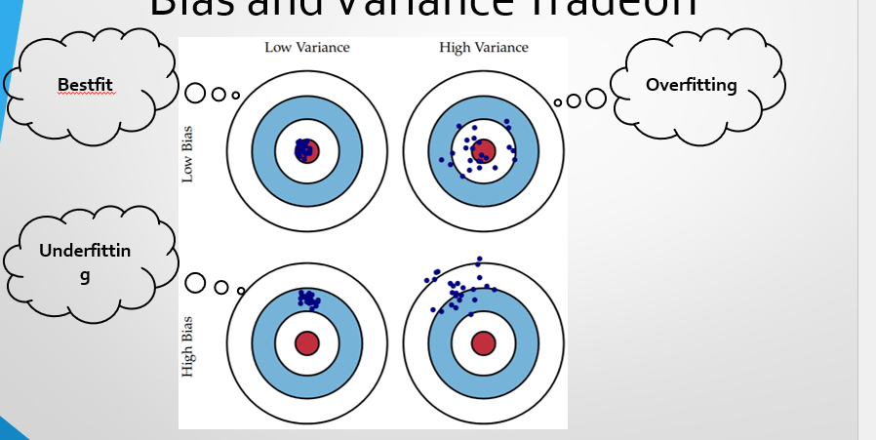
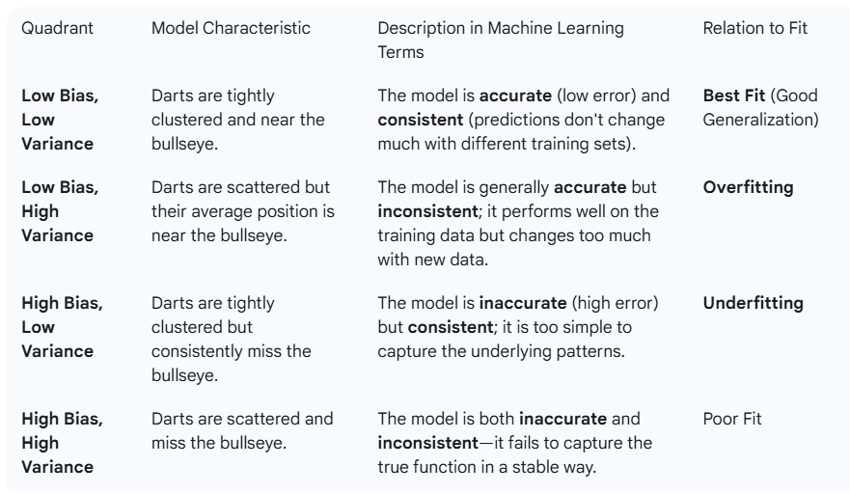
When Both Bias and Variance Are High (Worst Case)
This is the worst situation for a machine learning model.
It means the model is doing everything wrong — it’s both too simple and too unstable.
What It Means
- High Bias: The model doesn’t learn the real pattern (it’s too basic).
- High Variance: The model also changes a lot if we train it on slightly different data.
So, the model:
- Performs badly on training data (because of high bias).
- Performs badly on test data (because of high variance).

Lecture 11
Confusion Metrix
Model Evaluation
Model evaluation means checking how well a trained model works on new, unseen data.
Goals
- Check Accuracy:
To see how correct the model’s predictions are.
- Test Generalization:
To find out if the model can perform well not only on training data but also on new data it has never seen before.
- Find Problems (Overfitting or Underfitting):
  - Overfitting: The model learns training data too well but fails on new data.
  - Underfitting: The model is too simple and cannot learn the data properly.
- Compare Models:
To choose which model or settings (hyperparameters) give the best performance

Evaluation Metrics
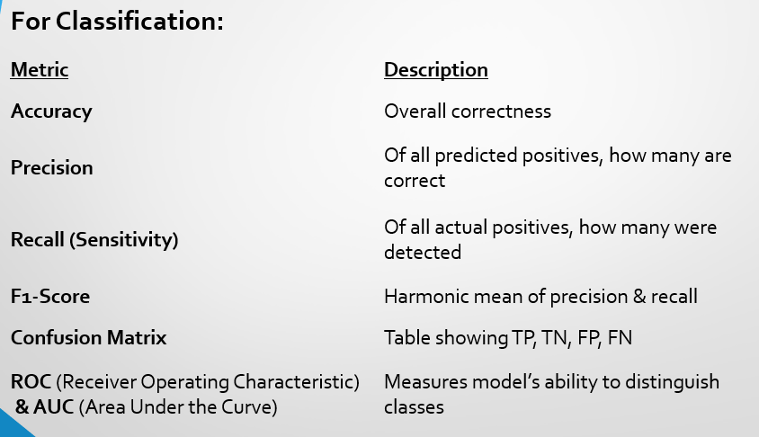
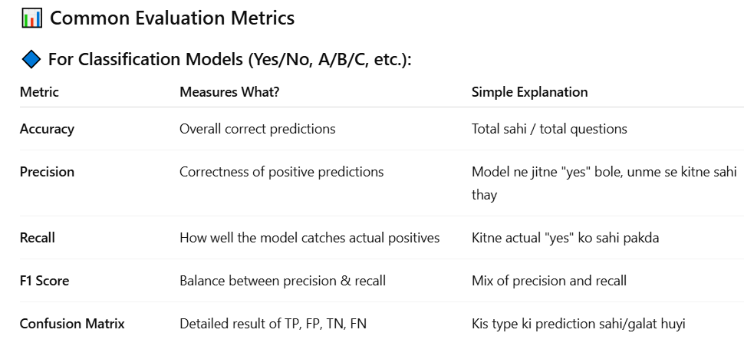
Confusion Matrix
A confusion matrix is a table that summarizes the model’s performance by comparing predicted labels with actual labels.

It shows how many predictions were:
- Correct, and
- Incorrect, for each class.
Confusion Matrix
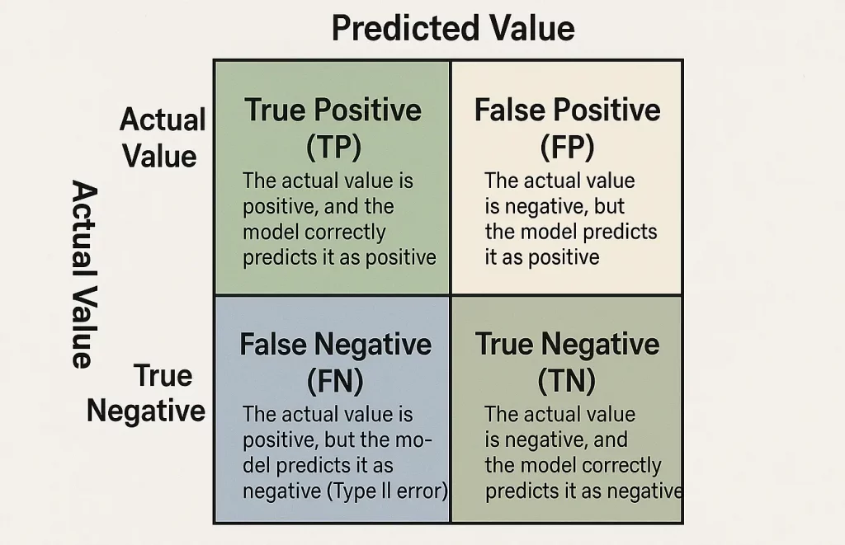
Common Evaluation Metrics
1. Accuracy
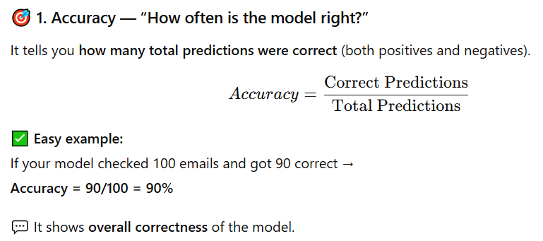

2. Precision
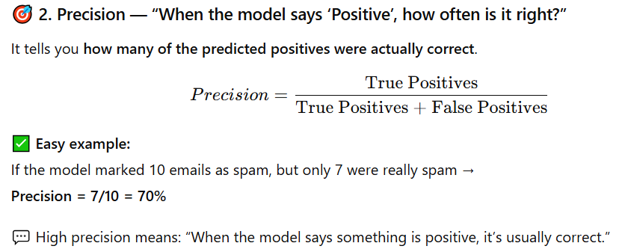
3. Recall
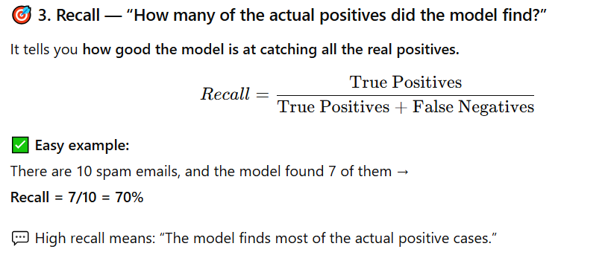
4. F1-Score
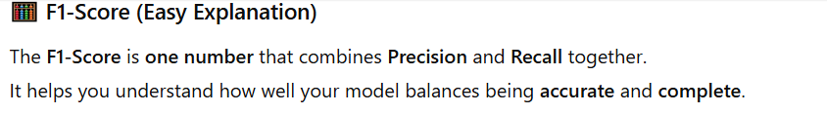
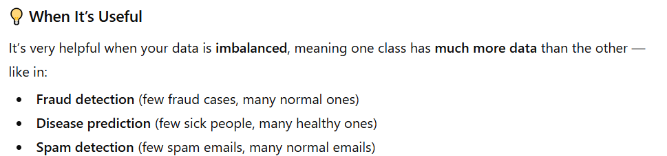
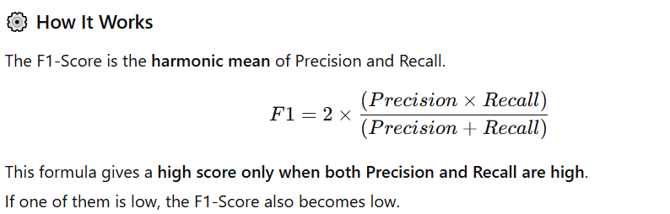
5. AUC/Roc
AUC–ROC is a way to check how well a model can tell the difference between classes,
like between spam and not spam, or disease and no disease.
What it means
ROC stands for Receiver Operating Characteristic curve.
It’s a graph that shows the relationship between:
- True Positive Rate (TPR) → also called Recall
- False Positive Rate (FPR) → how often the model predicts “positive” incorrectly.
Note: A model with high AUC gives more correct separations — it knows how to tell one class apart from the other more confidently.

Example of Confusion Matrix
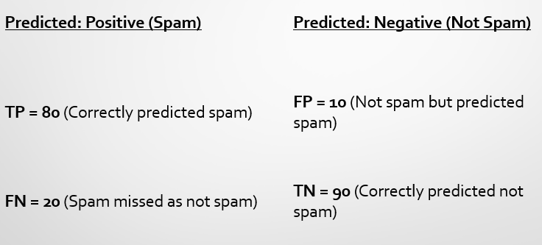
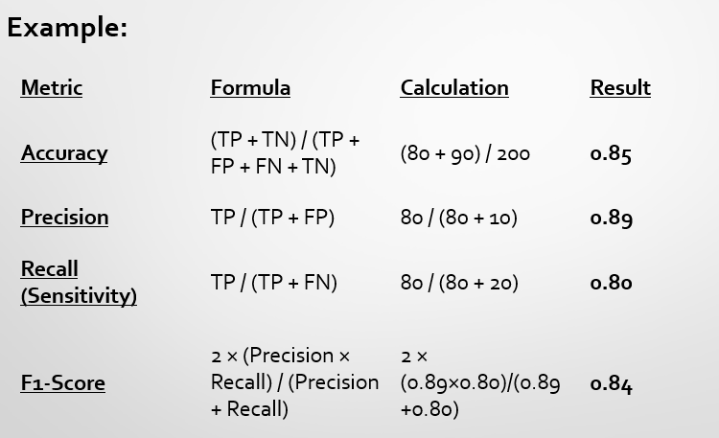
Example Summary
- The model correctly predicts 85% of all emails.
- It misses 20 spam emails (FN).
- It flags 10 normal emails as spam (FP).
Lecture 12
Unsupervised Machine Learning
Unsupervised Learning
Unsupervised learning is a type of machine learning where the computer is given data without any labels —
meaning we don’t tell it the correct answers or categories.
Goal
The goal is for the computer to find patterns or groups in the data on its own,
without being told what’s right or wrong.
How it works
- The model looks at the data and tries to organize or group similar things together.
- It learns hidden structures and relationships inside the data.
Examples
- Clustering: Grouping similar data points together.
Example: K-Means, Hierarchical Clustering
(like grouping customers by buying habits)
- Dimensionality Reduction: Simplifying large data while keeping important information.
Example: PCA (Principal Component Analysis)

Clustering
Clustering is a type of unsupervised learning where the computer groups similar data points together.
Goal
The main goal is to make clusters (groups) so that:
- Things in the same cluster are very similar to each other.
- Things in different clusters are very different from each other.
Example 1
Imagine you have data about many customers — how much they spend, what they buy, and how often they shop.
The computer can group them automatically into clusters, like:
- Cluster 1: Budget Buyers (spend less, shop often)
- Cluster 2: Luxury Buyers (spend more, shop rarely)
Example 2
- A company studies people’s body measurements (height, weight, chest size, etc.).
- Instead of making a separate shirt for every person (too costly),
they group people with similar sizes into clusters:
→ Small, Medium, and Large.
- This way, each group gets a shirt that fits them well enough — not perfect for everyone, but practical.
In short: Clustering helps make general size groups instead of one-size-fits-all or custom-made for each person.

Types of Clustering
There are mainly two types of clustering methods:
- Hierarchical Clustering
- Partitional Clustering
1. Hierarchical Clustering
This type builds a hierarchy (a tree-like structure) of clusters.
It works in two ways:
(a) Agglomerative Clustering (“Bottom-Up”)
- Start with each data point as its own cluster.
- Then, gradually merge the most similar clusters together.
- Continue merging until all points are in one big cluster (or until a stopping point).
Example:
Start with 5 people → first group 2 similar ones → then 3 together → finally one big group.
So, it builds clusters from bottom to top.
(b) Divisive Clustering (“Top-Down”)
- Start with all data points in one big cluster.
- Then split it into smaller clusters based on differences.
- Keep dividing until you get many small, meaningful clusters.
So, it works from top to bottom — opposite of agglomerative.
2. Partitional clustering
- Determine all clusters at once.
- K-means and derivatives
Distance Matrix
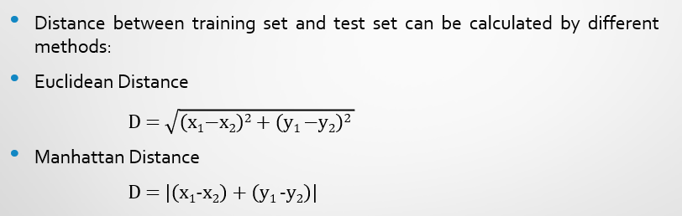
Aspects of Clustering
When we do clustering, there are a few important things to think about that decide how good the grouping is.
1. Distance (or Similarity) Function
- This tells the computer how similar or different two data points are.
- If two points are close together, they are similar.
- If they are far apart, they are different.
- Common examples: Euclidean distance, Manhattan distance, etc.
Example: In customer data, two people who spend about the same amount are “close,” meaning similar.
2. Clustering Quality
To check if our clusters are good, we look at two main things:
(a) Intra-cluster distance → should be small
This means points inside the same cluster should be very close to each other.
(Smaller distance = more similar)

(b) Inter-cluster distance → should be large
This means different clusters should be far apart from each other.
(Larger distance = better separation)
So, good clustering = tight groups + clear separation.
3. Quality Depends On
The quality of clustering depends on:
- The algorithm you use (like K-Means or Hierarchical)
- The distance function chosen
- The type of data or application (for example, people, images, products, etc.)
Agglomerative Clustering
It’s a hierarchical clustering method.
- Start with each data point as its own cluster.
- Then, gradually merge the most similar clusters together.
- Continue merging until all points are in one big cluster (or until a stopping point).
- Results are often visualized using a dendrogram (tree-like diagram).
Example:
Start with 5 people → first group 2 similar ones → then 3 together → finally one big group.
So, it builds clusters from bottom to top.
Agglomerative Clustering Steps
- Start: Each data point = its own cluster.
- Compute distances between all clusters (initially, individual points).
- Merge the two closest clusters.
- Recompute distances between new clusters and the rest.
- Repeat until:
- All points are in one big cluster, or
- A stopping condition is reached (e.g., desired number of clusters).
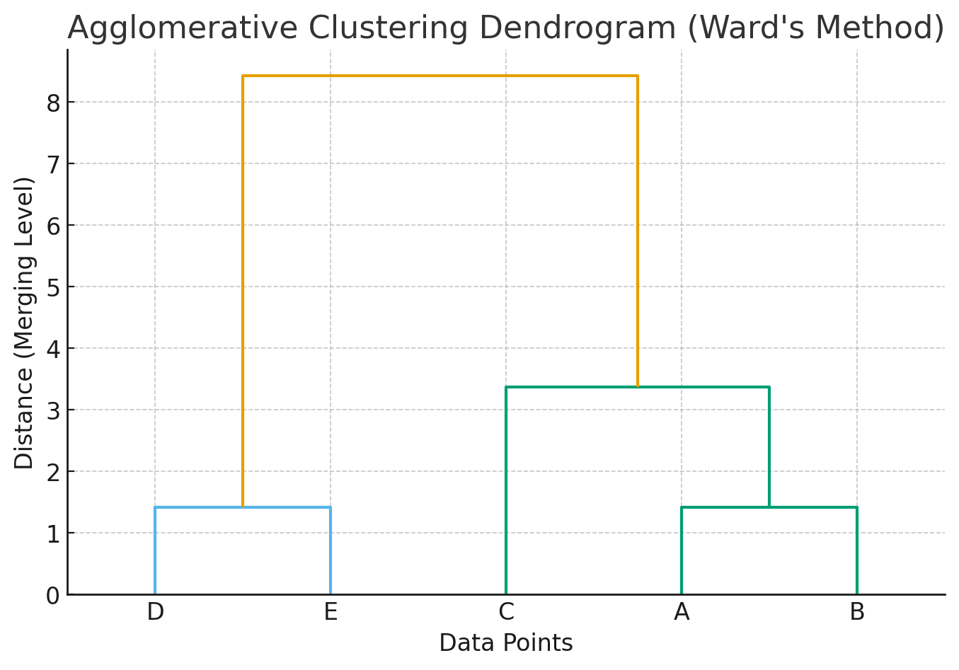
Advantages
- No need to pre-specify number of clusters (can decide by cutting the dendrogram).
- Produces a clear hierarchy.
- Works well for small datasets.

Limitations
- Computationally expensive for large datasets (distance matrix grows quickly).
- Sensitive to noise/outliers.
- Choice of linkage method can change results.
Divisive Clustering
It’s the opposite of agglomerative.
Top-down approach:
- Start with all data points in one big cluster.
- Iteratively split clusters into smaller ones until each point is its own cluster (or desired number of clusters).
Both Agglomerative and Divisive are part of Hierarchical Clustering.
Divisive Clustering Steps
- Start: All points are in a single cluster.
- Choose a cluster to split (usually the one with the largest dissimilarity).
- Split it into two smaller clusters.
- Repeat splitting until:
- Every point is its own cluster, or
- You reach the required number of clusters.
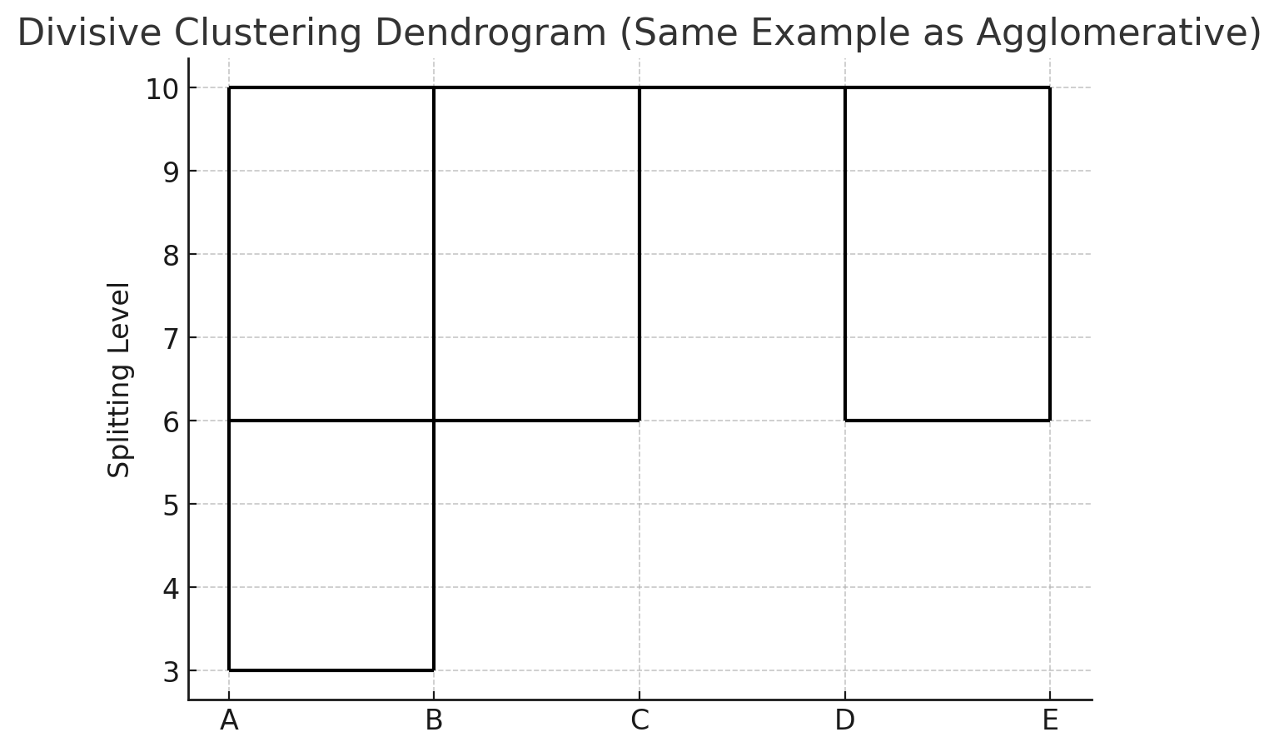
Advantages
- More accurate in some cases
- Divisive clustering looks at the whole dataset first before splitting it.
- Because it sees the overall structure, it can sometimes make more accurate groups.
- Good for naturally big clusters
- It works well when your data clearly starts as one big group
that can be divided into smaller, meaningful subgroups.
- Example: A company with all customers together, later divided into
“frequent buyers,” “occasional buyers,” and “rare buyers.”

Limitations
- Slow and expensive to compute
- Since it checks the whole dataset before splitting, it needs more time and power than the agglomerative (bottom-up) method.
- Not used very often
- Because it’s more complex and slower, researchers and data scientists usually prefer agglomerative clustering in practice.
Lecture 13
Ensemble Learning
Ensemble Learning
Ensemble learning means using many models together instead of depending on just one model.
Each single model may be weak or not very accurate, but when we combine their results, the final answer becomes more accurate, more stable, and works better on new data.
Why Use Ensemble Learning?
A single model can make mistakes because it might:
- Overfit: it learns too much from the training data and does not work well on new data.
- Have high variance or bias: sometimes it guesses too differently every time (high variance) or it always guesses in one direction (high bias).
- Be sensitive to noise: small errors or random data can confuse it.

When we combine many models, we get:
- Less variance: results become more stable.
- Less bias: the combined model makes more balanced decisions.
- Better performance: the final predictions are more accurate.
Basic Idea
Imagine you go to 5 different doctors to check what illness you have.
Each doctor might give a slightly different answer.
If you combine their opinions (like majority vote or average),
you will get a more reliable and accurate final decision.
Same idea in Machine Learning
Instead of trusting one model, we use many models:
$$\text{Final Prediction}=f_{1}(x)+f_{2}(x)+f_{3}(x)+⋯+f_{n}(x)$$
This means the final answer is made by combining all models’ outputs,
which makes the prediction stronger, more stable, and more accurate.
Types of Ensemble Methods
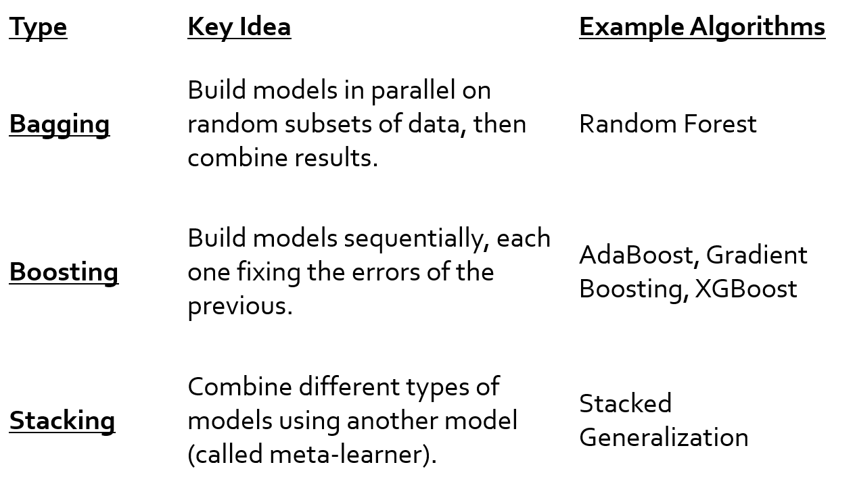
Common Combination Strategies
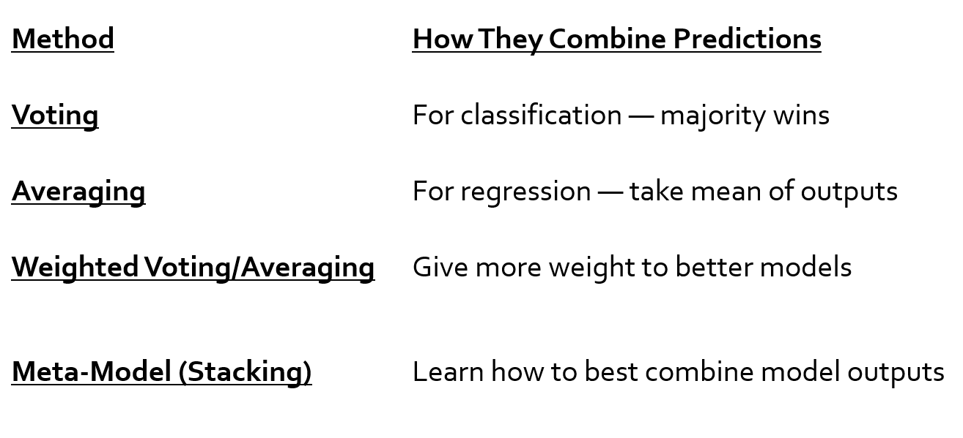
Advantages
Higher accuracy
Because many models work together, the final prediction becomes more correct.
Reduced overfitting
Ensemble methods don’t get easily “tricked” by training data.
They work better on new, unseen data.
Works well for both classification and regression
Whether the task is classifying (cat/dog) or predicting numbers (price, temperature),
ensemble methods perform strongly in both.
Disadvantages
More computational cost
It uses many models at the same time, so it needs more time and more computer power.
Harder to interpret
Since many models are combined, it becomes difficult to understand how the final decision was made.
May not work well if all models are similar or very weak
If the models are too similar, they will make the same mistakes.
If the models are too weak, combining them will not improve performance much.
Bagging (Bootstrap Aggregating)
- It’s an ensemble method that builds multiple independent models in parallel and then combines their predictions (by voting or averaging).
- “Train several models on different random subsets of the data, then combine their predictions to reduce variance and overfitting.”
Bagging (Bootstrap Aggregating)
Steps of Bagging
- Bootstrap Sampling
  - Randomly select samples with replacement from the original dataset.
  - Each sample becomes a training subset (same size as original).
- Train Models in Parallel
  - Train a base model (like a Decision Tree) on each subset.
- Aggregate Predictions
  - For classification → use majority voting
  - For regression → use average prediction
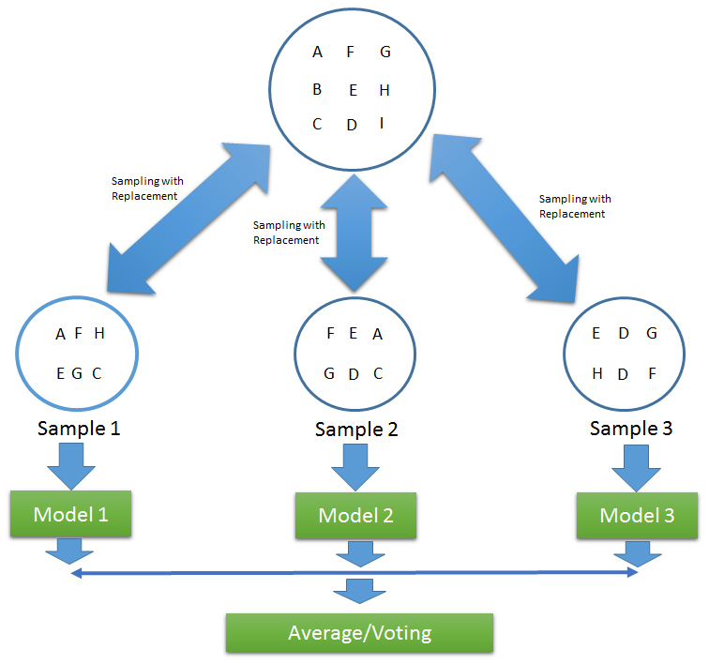
Bagging (Bootstrap Aggregating)
Each model gets a slightly different dataset
We create many new training datasets by randomly picking data with replacement.
So every model sees a different version of the data.
Models’ errors become uncorrelated
Because each model learns from different data,
their mistakes are not the same.
Averaging reduces variance
When we average all model predictions, the random mistakes cancel out.
This makes the final result more stable and less sensitive to noise.

Bagging (Bootstrap Aggregating)
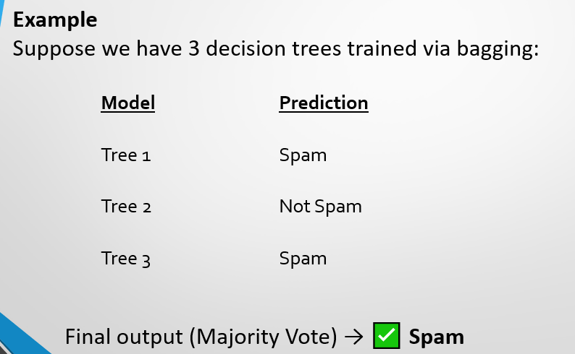
Random Forest
Random Forest = Bagging + Random Feature Selection
It’s a bunch of Decision Trees working together (an ensemble). Where each tree is trained on:
- A random subset of data (bootstrapping)
- A random subset of features (feature sampling)
Random Forest
Algorithm Steps
- Select random samples (with replacement) → Bootstrap samples.
- Select random subset of features for each tree.
- Grow Decision Trees to full depth.
- Combine predictions of all trees:
  - Majority vote (for classification)
  - Average (for regression)
Key Difference from Bagging
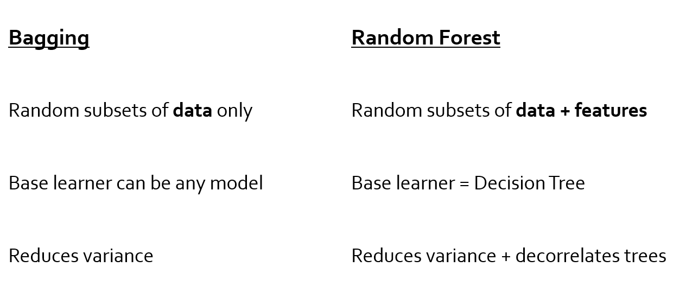
Random Forest
Example
Each tree might focus on different patterns:
- Tree 1: looks at “email length”
- Tree 2: looks at “number of links”
- Tree 3: looks at “sender reputation”
By averaging their opinions → you get a balanced, generalizable model.
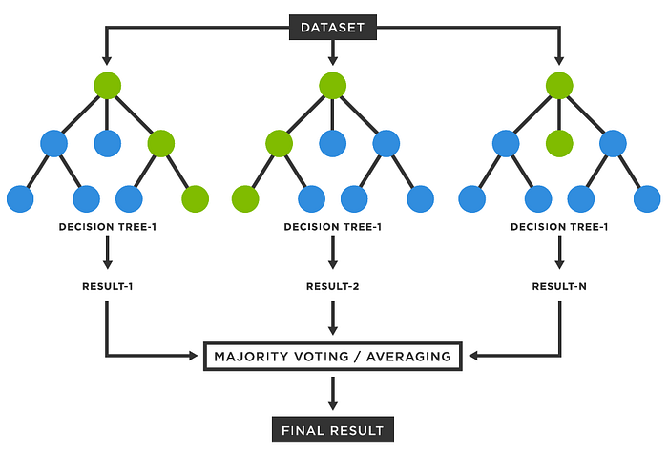
Lecture 14
Ensemble Learning Boosting
Boosting
Boosting is a method where you build many small models one after another.
Each new model tries to fix the mistakes made by the model before it.
It takes weak learners (like very small decision trees that are not very powerful alone) and combines them to make one strong model.
It does this by paying more attention to the examples that were hard to classify earlier.
So in simple words:
👉 Boosting = many weak models + each one learns from previous mistakes + together they become a strong model.
Boosting
- Start with a weak model
Make a simple model first (for example, a tiny decision tree). It will make mistakes — that’s expected.
- See which examples were wrong
Test the model and find the data points it misclassified (the hard ones).
- Give more importance to the hard examples
Increase the “weight” or focus on those wrong examples so the next model cares more about them.
- Train another weak model that focuses on those hard examples
Build a new simple model. Because the hard examples now have higher weight, this model will try harder to get them right.
- Repeat steps 2–4 many times
Keep adding more weak models, each one correcting errors of the earlier ones.
- Combine all the models’ answers
Put all models together — usually by adding up their predictions or using a weighted vote — to make one final strong prediction.
Analogy
Each new learner boosts the performance of the ensemble — like a teacher giving more attention to the students who struggled in the last quiz.

Example: AdaBoost
- Starts with equal weights for all samples.
- After each weak model:
  - Misclassified samples get higher weights.
  - Correct ones get lower weights.
Gradient Boosting
Gradient Boosting makes boosting better by reducing the overall error step by step.
Instead of changing the importance (weights) of data points like AdaBoost, Gradient Boosting:
- Looks at how much the previous model was wrong (the residuals).
- Build the next model to fix those mistakes.
So, each new model learns from the errors left by the previous one, and together they make a strong final model.
Gradient Descent
Gradient Descent is an optimization algorithm used to minimize a loss function by moving step-by-step in the direction of the negative gradient (the direction of steepest descent).
Think of Gradient Descent like this:
You are standing on a hill and want to reach the lowest point. You can’t see far, so you just look around, find the direction that goes down, and take a small step that way. You keep doing this step by step until you reach the bottom.

Loss Function
- The loss (or error) measures how far off a model’s predictions are from the true values.
- A big number means the model is making big mistakes, and a small number means it’s doing well.
- The goal of the model is to make this number as small as possible.
- To do this, we change the model’s settings (weights) little by little until the mistakes are very small
Gradient Boosting
- Gradient Boosting tries to make predictions more accurate by reducing mistakes (loss), just like Gradient Descent.
- But instead of changing numbers (weights) inside one model, it adds new small models step by step.
- Each new model focuses on fixing the mistakes of the previous models, going in the “direction” that reduces the error the most.
How It Works:
- Start with an initial prediction (e.g., mean for regression).
- Compute residuals (actual − predicted).
- Fit a new weak learner (e.g., small tree) to predict these residuals.
- Add this new learner’s predictions to the previous model, scaled by a learning rate η.
- Repeat for many round
In Simple Words:
Gradient Boosting builds a strong model step-by-step,
where each new model corrects the errors of the previous one.
Stacking (Stacked Generalization)
Stacking means you use many different models together (like a Decision Tree, Random Forest, Logistic Regression).
Each model makes its own prediction.
Then you use another model, called a meta-learner, whose job is to look at all those predictions and decide the best final answer.
Think of it like this:
- Several students (models) give their answers.
- A teacher (meta-learner) looks at all the answers
- The teacher decides the best final answer by learning which student is usually right.
Stacking
How It Works:
- Level 0 (Base Models):
Train several different models on the same dataset.
Example: Decision Tree, Logistic Regression.
- Level 1 (Meta Model):
Take predictions from base models as input features,
and train a meta-learner (e.g., Logistic Regression) to combine them.
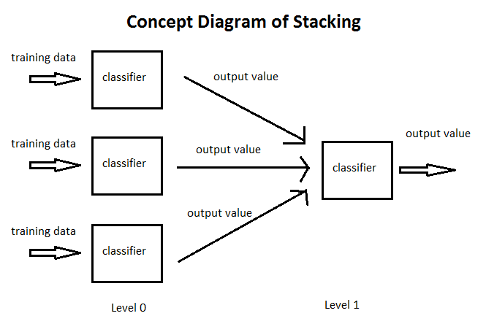
Stacking
Advantages
Combines strengths of different algorithms
Because stacking uses multiple models and lets each one learn different patterns in the data.
Often achieves higher accuracy than any single model
Because the meta-learner learns how to mix their predictions to correct each model’s mistakes.
Reduces risk of model bias
Because no single model dominates — their combined output balances individual biases.

Disadvantages
Computationally expensive
Because many models must be trained and used together instead of one.
More complex to implement and tune
Because you must choose base models, tune them, and then also tune the meta-learner.
Harder to interpret
Because combining multiple models makes it difficult to see which model influenced the final decision.
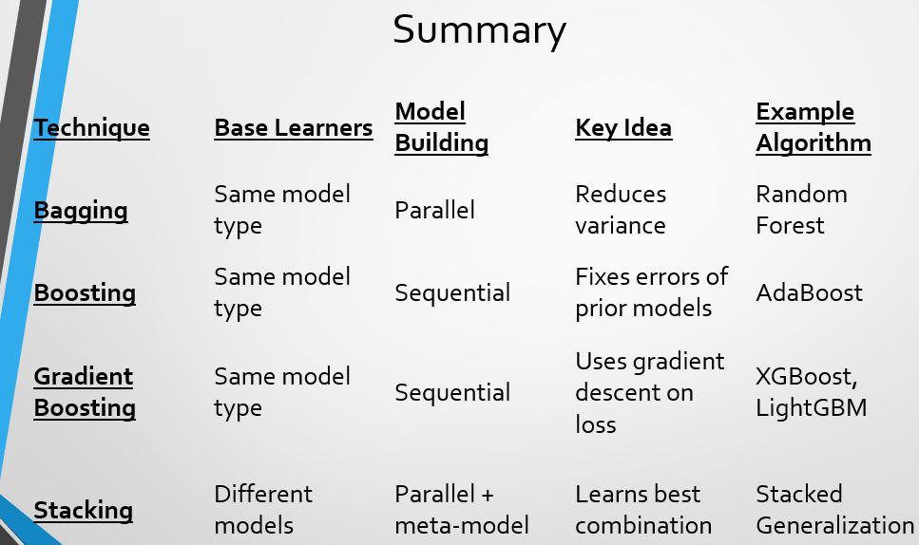

Lecture 15
K-Mean Clustering
K-Means Clustering
K-Means is an unsupervised machine learning algorithm used to group similar data points into clusters based on their features.
K-Means Clustering
How It Works
- Choose number of clusters (K) — you decide how many groups you want.
- Initialize centroids — pick K random points as starting “centers.”
- Assign points — each data point goes to the nearest centroid (using distance, e.g., Euclidean).
- Update centroids — move each centroid to the average position of the points in its cluster.
- Repeat steps 3–4 until the centroids stop moving (converge).
K-Means Clustering
Advantages
- Simple and fast
- Works well when clusters are well separated
- Scales to large datasets
Disadvantages
- You must choose K manually
- Sensitive to initial centroids
- Struggles with non-spherical or uneven-sized clusters
